Neurotransmission
Histamine is a neurotransmitter that regulates wakefulness, attention, and arousal.

Noise-induced arousal: The role of histamine in behaviour
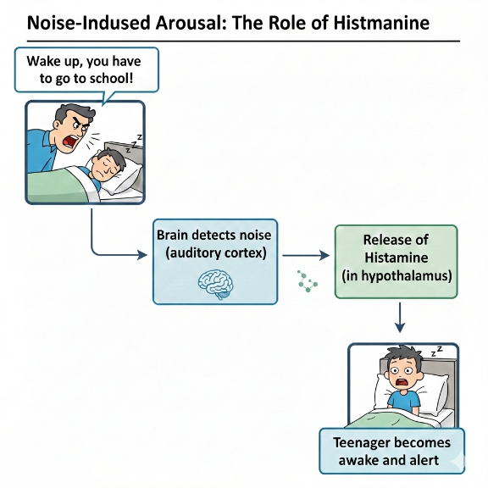
Note that histamine is also associated with allergic reactions, but for this activity, the focus is only on histamine’s role in wakefulness, attention, and arousal behaviour.

Stage 1. Synthesis (production and storage) Histamine is synthesised inside histaminergic neurons located in the hypothalamus, when an amino acid (obtained from dietary protein) is converted into histamine by an enzyme. Histamine is then packaged into small sacs called synaptic vesicles in the axon terminal (at the end of the neuron) for storage near the presynaptic membrane (the membrane at the end of the sending neuron) where it remains stored until the neuron is activated.
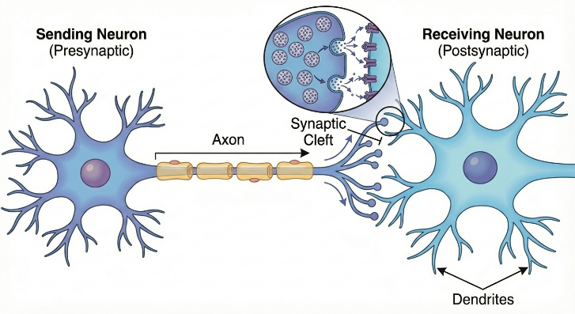
Stage 2. Action potential arrival When the neuron receives a signal (such as light exposure detected by the eyes, the body's circadian clock signalling wakefulness, or an arousing sensory stimuli, e.g. the sound of a parent shouting at their sleepy teenager to wake up for school!), an action potential (electrical impulse) travels down the axon to the axon terminal where the synaptic vesicles are located.
Stage 3. Release The action potential causes voltage-gated calcium channels to open and calcium ions rush into the axon terminal and trigger the synaptic vesicles to fuse with the presynaptic membrane. Through a process called exocytosis, histamine is released into the synaptic cleft (the tiny gap between neurons, which is about 20-40 nanometers wide).
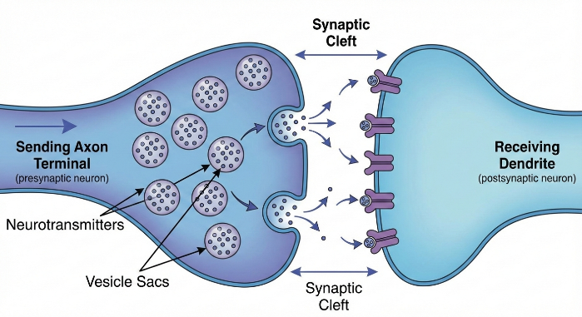
Stage 4. Binding to receptors Histamine molecules spread out across the synaptic cleft and bind to specific histamine receptors on the postsynaptic membrane (the receiving neuron). There are four types of histamine receptors: H1 receptors: Involved in arousal, wakefulness, and allergic responses; H2 receptors: Regulate stomach acid secretion and some cardiovascular effects; H3 receptors: Act as auto-receptors (negative feedback) and regulate other neurotransmitters; and H4 receptors: Primarily involved in immune responses.
Stage 5. Signal transduction (effect on receiving neuron) When histamine binds to its receptor, it triggers changes in the postsynaptic neuron and depending on the receptor type and location, this can: (i) Make the receiving neuron more likely to fire (excitatory effect) - most common with H1 and H2, (ii) Trigger a cascade of chemical reactions inside the cell, (iii) Open or close ion channels, or (iv) Activate second messenger systems.
Stage 6. Behavioral outcome The activation of histamine pathways throughout the brain produces observable behavioural and cognitive effects, including: (i) Increased wakefulness and alertness - the person feels awake and conscious rather than drowsy, (ii) Enhanced attention and focus - improved ability to concentrate on tasks and respond to stimuli, (iii) Improved cognitive performance - better memory encoding and information processing, and (iv) Suppressed appetite - reduced motivation to eat. This explains why antihistamine medications (which block H1 receptors in the brain) cause drowsiness and reduced alertness as a side effect.
Stage 7. Termination of signal Eventually, the signal must be stopped so the neuron can respond to new signals. For histamine, termination occurs through (i) Reuptake: Some histamine is taken back into the presynaptic neuron through transporters and can be repackaged into vesicles for reuse, (ii) Enzymatic Breakdown: Histamine is metabolized (broken down) by enzymes and eventually cleared away, or (iii) Diffusion: Some histamine simply diffuses away from the synapse.

