How to conduct a thematic analysis
Thematic analysis is a method for identifying, analysing, and reporting patterns (or themes) within qualitative data, often interview transcripts or text-based data. Braun and Clarke’s widely used six-phase approach includes: (1) familiarising yourself with the data, (2) generating initial codes, (3) searching for themes, (4) reviewing themes, (5) defining and naming themes, and (6) producing the final report. Their approach encourages reflexivity, transparency, and detailed interpretation of meaning.
Virginia Braun and Victoria Clarke are psychologists and qualitative research experts who developed this structured approach to thematic analysis. Braun is a professor at the University of Auckland in New Zealand, and Clarke is based at the University of the West of England, Bristol. Their paper, Using thematic analysis in psychology (2006) helped establish thematic analysis as a distinct and rigorous method. Since then, they have continued to publish widely on qualitative methods, advocating for reflexive and transparent practices in thematic analysis.
To conduct a thematic analysis of an interview transcript or text article, start by familiarizing yourself with the content, i.e. read and re-read the text to fully understand its surface meaning as well as any implied meanings (but be careful not to distort any implied meanings). At this stage, it’s useful to take notes on recurring ideas, significant phrases, or anything that stands out as potentially meaningful.
The next step is coding. Highlight segments of text that are relevant to the research question, e.g. words, sentences, or paragraphs. Assign short, descriptive labels (codes) to each excerpt. These codes should summarise the segment’s idea, such as ‘identity conflict’, ‘resistance’, or ‘community support’. Coding can focus on the explicit (semantic) content of the text, or on underlying (latent) meanings – or both.
Examine the codes for patterns and begin grouping related codes into broad themes. A theme captures an important idea about the data in relation to your research question. It can be helpful to use visual tools, like charts or mind maps, to see how codes cluster together. Next, review the themes to ensure they accurately reflect both the coded data and the article/transcript. Some themes may need to be refined, combined, or discarded. Always be careful not to read more into the text than what is there – assumptions can become significant biases which degrade the analysis’ validity and credibility.

Define each theme and name them in a concise, informative way. These definitions should clarify how each theme contributes to the overall understanding of the text with respect to the research question.
Summarise your analysis by presenting and explaining each theme, using evidence, such as direct quotes, from the article/transcript to support your interpretation. Aim to show how the themes connect with and offer cautious insight into the article’s deeper meanings. Conclude by summarising your findings and reflect on their implications – what do you think they mean?

Worked example
News article: ‘I don’t think my brain should have gone through that’: five young people on their experience of smartphones as teens
By Katie Cunningham, June 27th, 2025
Debate and anxiety about teen and preteen access to smartphones and social media is raging. One paper has likened smartphones to a “parasite” on our brains, while another study suggests moderate use of social media does not have a harmful effect on young people. In the US more than 100,000 parents have joined an online pledge to delay giving children smartphones until at least the eighth grade and in Australia a ban on under-16s using social media will come into effect in December. Despite all this, OECD figures released in May show 70% of 10-year-olds and 98% of 15-year-olds have internet-connected smartphones.
So is giving teenagers smartphones that big a deal?
To find out, we asked four twentysomethings who got a smartphone at some point in their teen or preteen years – and one who didn’t.
‘I would have not let myself ever get TikTok’
Sienna Seychell, 21, Melbourne
I was about 11 when I got my first smartphone. But when I was six I got an iPod Touch so I had already been communicating with people that way. My brother installed Kik, the infamous app for predators, on the iPod – a bit concerning to think about now! But I just used it to text my friends from school. I know a fair few of my friends went down a rabbit hole contacting people that they definitely shouldn’t have at that age.
I got social media in year 5 or 6. I convinced my mum to let me get Snapchat for the filters and I got Instagram shortly after. It definitely brought my friendships closer because I had a readily accessible means of communication outside school hours. I was cyberbullied in year 6, so that was a negative. But I feel like I put that aside to be able to talk with friends. I had a good experience of social media overall but it has contributed to friends’ severe eating disorders.
I think I would have been more outdoorsy had I not had a phone. I would have connected with nature more and hung out in the real world, instead of online all the time. I think it would have made a great impact on my mental health. I suffer from pretty bad anxiety and OCD and sometimes I feel that a big trigger is using my phone and being able to focus on things online that are outside my control. I would have hated a social media ban – but I would have gotten over it!
If I could go back I would have not let myself ever get TikTok. I think my attention span is so poor because of it and I really struggle to sit down and study or just do what I love doing without getting distracted. I can barely watch a movie for an hour without checking my phone a few times. I’m always on my phone.
‘I felt like everybody was judging each other’
Ella Jackson, 21, regional New South Wales
I was 12 when Mum took me to get an iPhone 5, so I had Instagram from a really young age. I grew up in a place called Penrose, which is in the NSW southern highlands. I liked emo music so I would spend a lot of time on my phone looking into that world. I found a sense of belonging on the internet, because there weren’t a lot of people around who liked the same things as me.
The bad side of it was Instagram models, obviously. Twelve-year-old girls shouldn’t be comparing themselves to 30-year-old women. I think I also became conscious of the fact that it seemed like a big deal to live a life that was “worth” posting on Instagram, especially in the later part of high school. It made me conscious of how people perceive others. I felt like everybody was judging each other all the time.
Studying I found so tricky, because the phone was always there and it was so easy to be distracted by it. I ended up having to film myself studying so I couldn’t go on my phone. And because my mum’s house was in a regional part of the highlands, there was no way out unless she was going to drive me 40 minutes into town. So I was just stuck at home all weekend and would just sit there streaming, which is crazy. It’s this huge amount of time that was not well spent.
When I got my driver’s licence, all of this changed. I could go places and see my friends. More interesting things came along and my brain was like, OK, you don’t need to be doing this any more.
‘It trained me to expect immediate contact’
Zach Karpinellison, 29, Sydney
I had a dumb phone until I was probably 15, then I pivoted to a cheap Android. On my dumb phone I had limited data and credit. So the clear difference was that, all of a sudden, you’re constantly messaging other people. I was in an era where schools had no sense of whether phones needed to be regulated, so you had your phone on you all the time. It was a real opportunity to have quite deep conversations with people, which would do a lot of the work of forming a friendship with them. It was also an opportunity to connect to a wider pool of people outside school. That was good – I liked that part of it.
But it trained me to expect immediate contact with everybody. I would feel a real panic and stress over not hearing back from people if they didn’t immediately write back. I carry that with me to this day – being stressed about someone not responding to me. As a teenager, you’re already full of anxiety and trying to figure out the world. Then you’re messaging someone at 2am and they drop off, and you spiral out into “something terrible has happened!” I don’t think my brain should have gone through that at that stage.
I had Facebook and Messenger, then Instagram towards the end of high school. Because I went through those different iterations of the internet, I am savvy about how to use these things but also have an ability to step away from it. I recognise when I’m being sold things in a way that people who are gen Z don’t necessarily.
But we were posting ourselves online and comparing the like counts [of Instagram posts]. That was, like, absolutely brain melting. It was not good.
‘I didn’t get a proper phone until I was 20’
Pearl Cardis, 24, Sydney
I had a Nokia brick phone in school. It was the equivalent of a party trick because I could toss it across the playground, or break in three pieces for the drama, and then put it back together – people’s eyes got so wide. But beyond that it was pretty rough.
I’m a very different person to what the mould looks like for the people I grew up with
Pearl Cardis
We were quite low-income. Mum had all of us on Vodafone so that we could do free Vodafone-to-Vodafone calls but we weren’t able to text anyone. So I could only really use my phone to call family. All around me it was Apple city – everyone else had an iPhone. I was not overly concerned with fitting in but I also didn’t have great friendships. I doubt being different in that way helps when you’re already kind of an oddball.
For me the dominant experience was one of stress and isolation because I had less independence and less ability to connect with people around me. It was difficult to travel anywhere or meet anyone because I couldn’t use maps or text friends. I remember getting off the bus one time and just being so panicked, in the middle of nowhere, with no way to contact anyone except an actual pay phone on the side of the road. I tried to call someone but they didn’t pick up.
I know that a lot of people had huge body image issues going through high school or were very concerned with trends and appearance – whereas I was just not conscious of that. I still had low self-esteem, which I think any young person will, but it was more through comparison to my peers than anyone online.
I didn’t get a proper phone until I was 20. I think I’m a very different person to what the mould looks like for the people I grew up with. I am able to go without my phone for an extremely long time without worrying about it. I feel less habituated to needing to check notifications all the time, and I hate [the pressure to] respond to people regularly.
But when TikTok came out there were periods where I would be trapped for five hours at a time scrolling. I just get so sucked in because I have no guardrails. It’s like a kid who doesn’t have sugar who gets access to sugar. Maybe these are things that it’s better to be trained to adapt to as you grow up, as opposed to the floodgates opening all in one go.
‘I would wake up and get straight on my phone’
Reinhard Holl, 24, Adelaide
I got an iPhone in year 7. I came to social media a little bit later, maybe midway through high school – it didn’t spark my interest that much at first. Later it became more of a fixation. I would say social media became a little bit of a negative thing in the way that I felt a lot of pressure to be perceived a certain way, put things online and keep up with the way that everybody else was using it in high school. But it also became a good way to interact with people.
The phone definitely affected my sleep. I would wake up and get straight on my phone and mentally reinforce having that immediate stimulus as a normal thing. I think it affected my attention span, too – it was this thing that I was focused on constantly.
If I could go back I wouldn’t have allowed myself to sleep with it in my room. But really, I feel like I got thrown in the deep end and learned how to have a phone that way. I now have a good dynamic with it – I know how to use it in a way that works well for me.
Source: https://www.theguardian.com/society/youngpeople
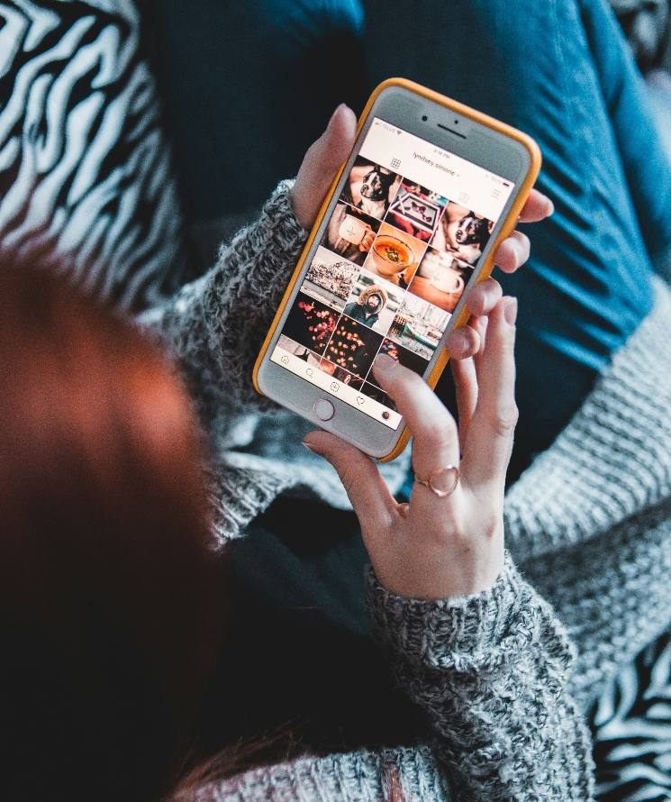
Thematic analysis
Research question: What are the perceived positive and negative effects of mobile phone and social media use during adolescence?

Phase 1: Familiarisation with the data
The data consists of five first-person accounts from young adults reflecting on their teenage experiences with smartphones and social media. The interviews include rich detail about emotional, cognitive, social, and behavioural effects. Each transcript was read multiple times, and preliminary observations were noted.

Phase 2: Generating codes
Examples of codes included:
- Early exposure, e.g., getting a smartphone in primary school
- Cyberbullying and social comparison
- Connection and belonging
- Distraction and reduced attention span
- Sleep disruption
- Online validation and anxiety over response time
- Pressure to curate an image
- Delayed access leading to resilience
- TikTok addiction and doomscrolling/deadscrolling
- Lack of regulation in early years

Phase 3: Searching for themes
Codes were grouped into broader, meaningful patterns. Emerging themes included:
- Accelerated social connection vs. superficiality and comparison
- Loss of focus and sleep disruption
- Emotional vulnerability and anxiety
- Delayed access as a form of resilience
- Ambivalence and adaptation over time

Phase 4: Reviewing themes
Themes are refined to be sure they reflect the data/text and have sufficient supporting data. Overlaps between themes, e.g., between anxiety and sleep loss, are acknowledged but not merged so that conceptual clarity is retained.

Phase 5: Defining and naming the themes
1. Accelerated social connection vs. Superficiality and comparison
Participants described smartphones and social media as a means to maintain friendships and discover communities of shared interest, especially when they felt they were geographically isolated (Ella, Zach). However, most participants discussed the pressure to present a curated image and the harmful effect of comparing themselves to influencers and even their peers, especially during early adolescence.
2. Loss of focus and sleep disruption
Sienna, Reinhard, and Ella all commented on how phone use had a negative effect on their ability to concentrate or study and linked it directly to their disrupted sleep and poor attention span. TikTok and frequent notifications were associated with overstimulation.
3. Emotional vulnerability and anxiety
A recurring theme was anxiety associated with online communication, e.g., anxiety related to being ignored or comparing likes (Zach). Cyberbullying (Sienna) and panic from lack of contact (Pearl) added to the participants’ emotional instability during their developmental years.
4. Delayed access as a form of resilience
Pearl’s experience stood out for not having a smartphone until age 20, which gave her a unique perspective. She commented that her lower engagement with phone and social media culture meant she had better self-regulation, felt less pressure to perform online, and felt less phone dependency, even though it also contributed to feelings of social isolation.
5. Ambivalence and adaptation over time
Many participants recognised the harm of phone use but described adapting and gaining control (Reinhard, Zach). They expressed the idea that smartphones are not inherently harmful but they needed structured use and boundaries, which they lacked as teenagers.


Phase 6: Writing the report
This thematic analysis explored the perceived positive and negative effects of mobile phone and social media use during adolescence, based on five personal accounts. The findings suggest that participants had complex relationships with phones which was influenced by the age of access, their social context, and their emotional development.
Theme 1: Accelerated social connection vs. Superficiality and comparison
Smartphones were described as tools to enhance friendships and provided a sense of belonging, especially for those living in isolated situations or with niche interests. Ella shared, ‘I found a sense of belonging on the internet, because there weren’t a lot of people around who liked the same things as me’. Zach explained that having a phone allowed for ‘quite deep conversations’ that helped form strong social connections.
However, participants also reported significant pressure to present ‘ideal’ versions of themselves, and negative effects of comparing themselves to others. Ella stated, ‘Twelve-year-old girls shouldn’t be comparing themselves to 30-year-old women’. Zach described the need to compare likes on posts as ‘absolutely brain melting’.
Theme 2: Loss of focus and sleep disruption
All participants reported cognitive effects of early phone use, including reduced attention span and disrupted sleep. Sienna said, ‘I think my attention span is so poor because of [TikTok]... I can barely watch a movie for an hour without checking my phone a few times’. Reinhard said, ‘I would wake up and get straight on my phone and mentally reinforce having that immediate stimulus as a normal thing’. The participants normalised these behaviours during adolescence but now view them with regret.
Theme 3: Emotional vulnerability and anxiety
Emotional instability, especially anxiety associated with online communication, was a common theme with participants. Zach said, ‘It trained me to expect immediate contact with everybody… I carry that with me to this day – being stressed about someone not responding to me’. Sienna admitted that social media use influenced her anxiety and OCD symptoms, while others such as Pearl described the emotional cost of isolation because of not having a connected device at all.
Theme 4: Delayed access as a form of resilience
Pearl’s experience of delayed smartphone access offered an interesting contrast; she described feeling left out socially and geographically, saying, ‘I remember getting off the bus one time and just being so panicked… with no way to contact anyone except an actual pay phone’. She also reported long-term benefits, such being able to detach from her phone easily: ‘I feel less habituated to needing to check notifications all the time’. This theme suggests late exposure may develop digital resilience, but it may come at the cost of social exclusion during adolescence.
Theme 5: Ambivalence and adaptation
Several participants expressed ambivalence, recognising both the harm and the value of their experiences, and described gaining control eventually. Reinhard said, ‘I feel like I got thrown in the deep end and learned how to have a phone that way. I now have a good dynamic with it’. Zach said his early exposure gave him ‘an ability to step away from it’. These insights challenge the simple narratives and suggest self-regulation skills can develop over time, albeit too late to avoid emotional costs.
Conclusion
Thematic analysis revealed that while smartphones and social media represent important opportunities for connection, self-expression, and entertainment, they also bring significant risks for adolescents, in relation to mental health, attention, and self-esteem. Most participants described their relationship with technology as simultaneously enabling and damaging, with long-term consequences still being understood. Rather than concluding that smartphones and social media are inherently harmful or beneficial, this study supports a balanced view: that young people can benefit from structured, developmentally appropriate exposure to phones and social media, alongside support for developing self-regulation, critical media literacy, and emotional resilience.

Strengths of the study
- Rich qualitative data: The use of first-person, narrative-style interviews allowed for honest reflections that quantitative studies may miss.
- Relevance: The participants are young adults reflecting on recent experiences, offering a timely insight into the effect of technology.
- Varied perspectives: Including someone who delayed phone access adds contrast.
Limitations of the study
- Small sample size: Only five participants, limiting the generalisability of findings.
- Lack of demographic diversity: Most participants are from urban Australia; perspectives from different cultural or socioeconomic backgrounds are missing.
- Retrospective reporting: Participants reflected on past experiences so they may be subject to memory bias or reinterpretation based on current beliefs.
- No formal triangulation: Without observational or quantitative data, conclusions rely solely on participants’ self-reported perceptions.



Summary: Thematic analysis
This a data analysis and interpretation method for identifying, analysing, and reporting patterns (or themes) within qualitative data, often interview transcripts or text-based data.
Braun and Clarke’s widely used six-phase approach includes:
(1) familiarising yourself with the data,
(2) generating initial codes,
(3) searching for themes,
(4) reviewing themes,
(5) defining and naming themes, and
(6) producing the final report.
The Braun and Clarke approach encourages reflexivity, transparency, and detailed interpretation of meaning.

