The Role of Culture in Human Behaviour: Culture, Perception, and Perspective
In Psychology, culture means the values, beliefs, norms, behaviours, and practices shared by a group of people. Culture influences how we think, communicate, behave, and perceive the world around us.
Examples of cultures from different contexts:
- Religious group – Orthodox Jewish Community This group’s culture is shaped by religious beliefs, practices, and traditions such as observing the Sabbath, observing kosher dietary rules, and valuing community prayer. Group members’ behaviour is influenced by religious teaching, which guides everything from dress to social roles.
- School community – International Baccalaureate (IB) students IB students loosely share a culture of academic curiosity, global-mindedness, and respect for inquiry. This culture encourages critical thinking, open-mindedness, and values such as integrity and responsibility, all promoted by the IB Learner Profile.
- Nationality – Japanese Culture
Japanese culture includes social norms around respect, politeness, and group harmony. Behaviours such as bowing, removing shoes indoors, and a preference for indirect communication reflect cultural values of humility, respect for elders, and collectivism.

Some human behaviour is described as culture-specific while some behaviour seems universal to humans in all cultures.
Examples of culture-specific behaviours:
- Greeting customs (e.g., bowing in Japan vs. handshakes in the US)
- Parenting styles (e.g., emphasis on independence vs. obedience)
- Attitudes to time (e.g., punctuality in Germany vs. flexibility in some South American cultures)
- Emotional expression (e.g., open expression vs. emotional restraint)

Examples of universal behaviours:
- Basic emotions, e.g., fear, joy, sadness
- Language development in early childhood
- Social bonding and the need for connection
- Facial expressions related to emotion (e.g., smiling when happy)

Article summary: Do people from different cultures perceive the world differently?
This article explores how culture may shape perception, particularly through the use of visual illusions. A study by Ivan Kroupin and colleagues found that people from the UK and US were more likely to see rectangles in the Coffer illusion, while rural Namibians were more likely to see circles.
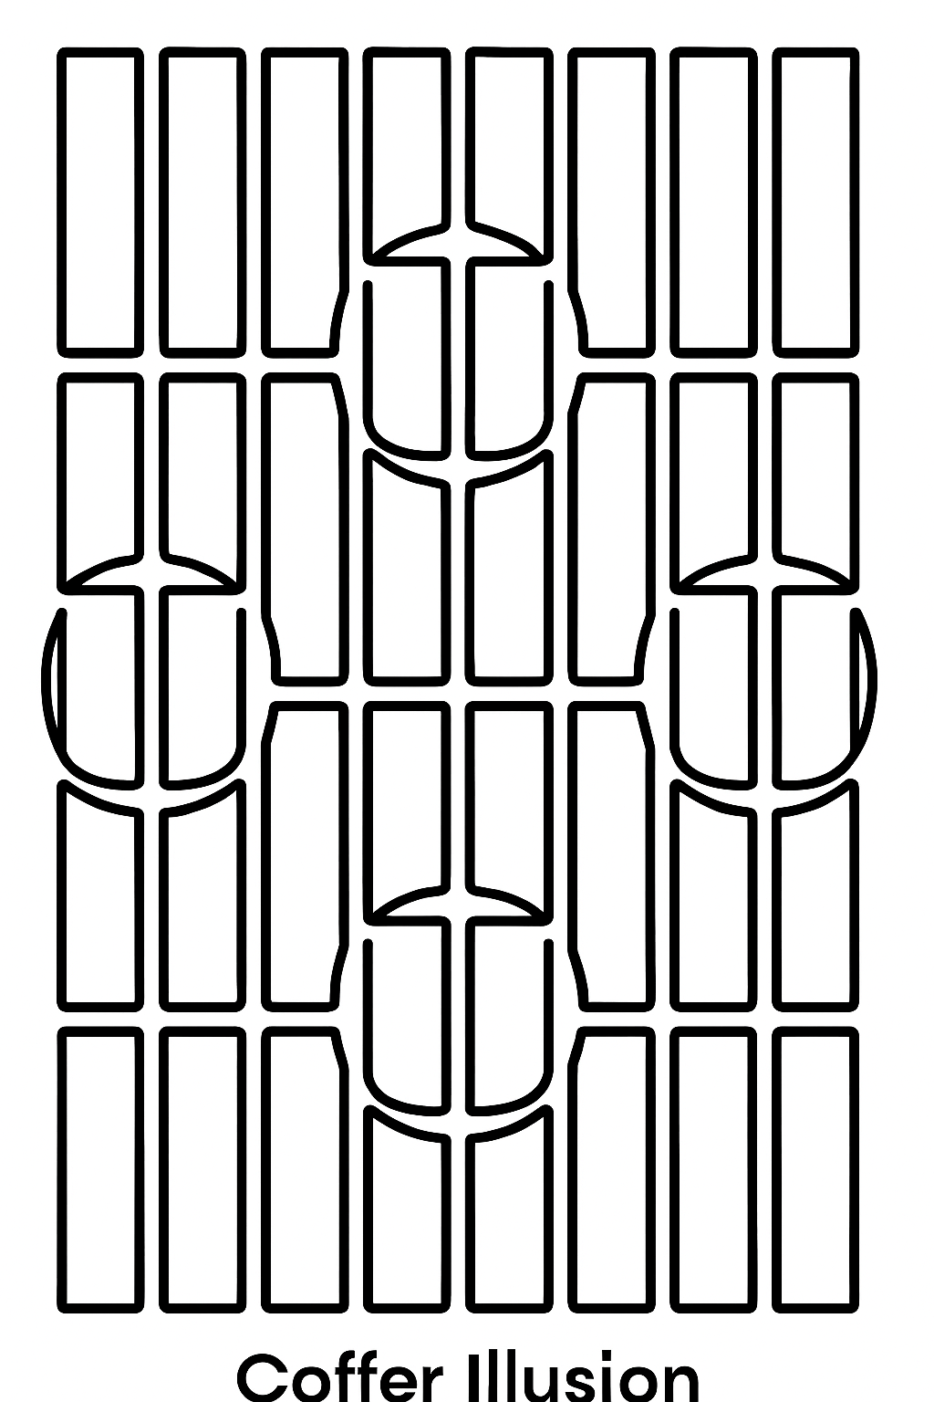
The Coffer Illusion: Do you see rectangles or circles?
This supports the Carpentered World Hypothesis, which suggests that people who live in environments dominated by straight lines and right angles, such as cities, develop different perceptual habits than those living in curved or natural environments.
A second study by Dorsa Amir and Chaz Firestone investigated the Müller-Lyer illusion, where two lines of equal length appear to be different because of the arrow shapes at the ends. They found that the illusion worked for everyone – including non-human animals and children who had recently gained sight – suggesting that this illusion is rooted in biology, not culture.
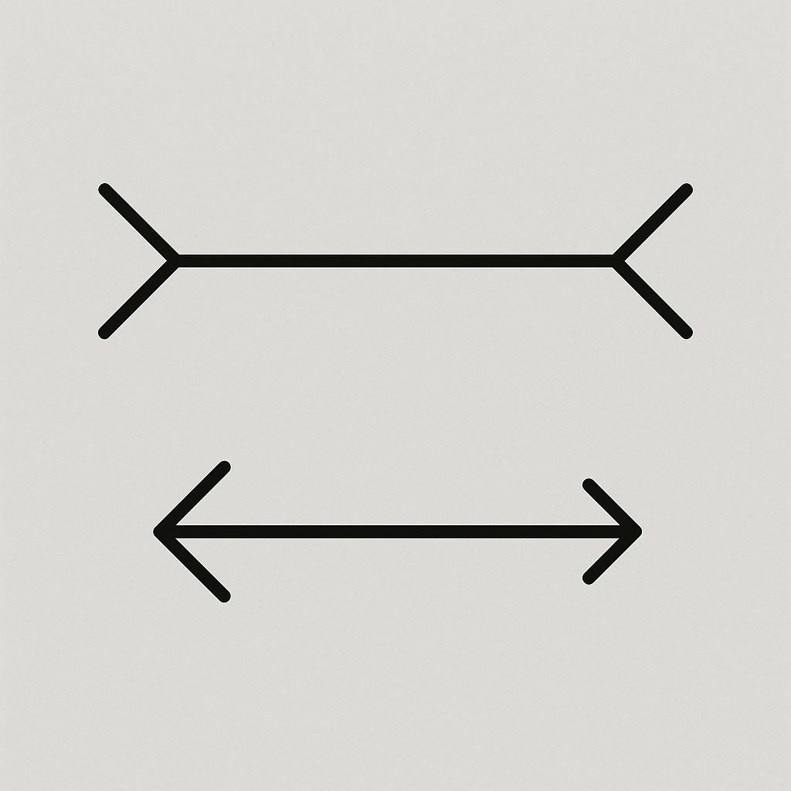
The Müller-Lyer illusion: Which of the two horizontal lines is longer?
These contrasting findings highlight that while culture can influence perception, not all perceptual experiences are culturally determined. The Coffer illusion may depend more on attention and familiarity with visual environments, while the Müller-Lyer illusion appears to reflect more universal brain processing mechanisms.
Source: https://www.theguardian.com/commentisfree/2025/jul/05/optical-illusions-see-world-perception

Linking Culture and the Concept of Perspective
The Concept of Perspective refers to the idea that our understanding of the world is shaped by our personal experiences, context, and cultural background. This article shows how culture can influence perception, suggesting that individuals from different cultural environments may quite literally ‘see’ the world differently. For example, those who grow up in environments full of straight edges and right angles may interpret visual information differently than those in more natural or circular environments. This supports the idea that Perception is not only a biological process but also a culturally influenced one.
Recognising the role of Perspective helps psychologists avoid cultural bias and ethnocentrism. It encourages a broader and more inclusive understanding of human behaviour, one that takes into account diversity both between and within cultural groups.

Vocabulary
- Culture: Shared beliefs, customs, and behaviours of a group.
- Perception: How we interpret and understand sensory information.
- Carpentered World Hypothesis: The idea that exposure to straight lines and right angles in architecture affects visual perception.
- Visual illusion: An image that misleads our perception – a form of Bias.
- Perspective: The viewpoint shaped by experience, culture, and context.
- WEIRD: Western, Educated, Industrialised, Rich, and Democratic – used to describe participants from these cultures in psychological research.
- Ethnocentrism: Judging other cultures by the standards of one’s own.
- Etic approach: Studying human behaviour from an outsider’s perspective, using universal concepts and categories.
- Emic approach: Studying human behaviour from an insider’s perspective, focusing on culture-specific meanings.

Questions
- Explain, using examples, the concept of Perspective.
- Describe the Carpentered World Hypothesis.
- Explain, with an example, that cultural environments may influence visual perception.
- Describe one cultural and one biological explanation for different perceptions of visual illusions. To what extent is Perception shaped by culture versus biology?
- Discuss how within-group variation in perception challenges cultural stereotypes.
- Compare and contrast the Coffer illusion and the Müller-Lyer illusion.
- To what extent does the article support the idea that culture influences Perception?
- Discuss the role of culture in human behaviour.

Please visit our website for more worksheets: www.TomCoster.com

