Worksheet: Applying Social Identity Theory to Conflict Resolution
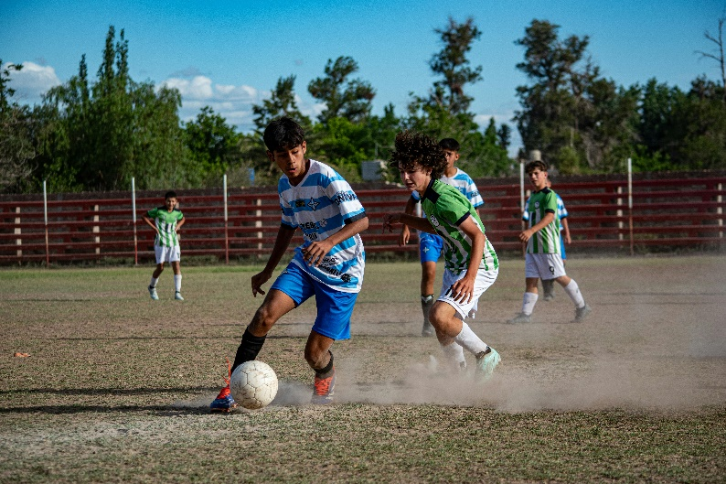
Address: Senior Police Officer Discusses Social Identity Theory and Conflict Resolution
Senior Officer Jackson: Good evening, community leaders. Thank you for gathering to address the ongoing conflict between immigrant youth and local youth in Melbourne. These clashes, while troubling, are not unique; they reflect broader social dynamics that can be explained and, more importantly, mitigated through Social Identity Theory (SIT).
SIT, developed by Henri Tajfel, explains how individuals derive a sense of identity and self-worth from their group memberships. When groups perceive each other as threats to their status or values, conflict is likely to arise. In our situation, local youth may see immigrant youth as outsiders encroaching on their space, while immigrant youth might feel marginalized and react defensively to assert their identity.
To address this, we must first understand the power of in-groups and out-groups. Each group’s identity is reinforced by contrasting itself with the other. Negative behaviors, such as street fights, often stem from this dynamic. However, SIT also offers a pathway to resolution: the introduction of a superordinate identity that transcends existing divisions.
One successful example comes from community sports programs. By creating mixed teams of immigrant and local youth, we can encourage them to work together toward shared goals. Through cooperation, they begin to see themselves as teammates rather than adversaries. This mirrors the findings of Muzafer Sherif’s Robbers Cave study, where previously hostile groups of boys overcame conflict by working on superordinate tasks that required collaboration.
Another strategy involves fostering mutual respect and dialogue. Educational workshops and cultural exchange events can provide opportunities for both groups to learn about each other’s backgrounds. When individuals move beyond stereotypes and recognize shared experiences, they are more likely to empathize and cooperate.
It’s also crucial to address systemic factors contributing to the conflict. Many immigrant youth face economic and social challenges that exacerbate tensions. Initiatives like mentorship programs and community support services can provide positive role models and resources, reducing the appeal of hostile group dynamics.
As leaders, we have a responsibility to promote unity. Highlighting a shared identity as Melburnians, for example, can provide a unifying narrative. Encouraging pride in their city and its diverse communities can motivate youth to protect rather than fight over shared spaces.
In conclusion, Social Identity Theory not only helps us understand the root causes of this conflict but also provides actionable strategies to resolve it. By fostering cooperation, mutual respect, and a shared sense of belonging, we can create a more harmonious community. I urge all of you to join us in implementing these initiatives and leading the way toward peace.
- What is Social Identity Theory (SIT)?
- Who developed SIT?
- How do in-groups and out-groups contribute to conflict?
- Why might local youth perceive immigrant youth as a threat?
- How do immigrant youth assert their identity in this situation?
- What is a superordinate identity, and how does it reduce conflict?
- Provide an example of a superordinate identity from the officer’s speech.
- How does the Robbers Cave study relate to the current conflict?
- What role do community sports programs play in resolving conflicts?
- How can cultural exchange events foster mutual respect?
- Why is it important to address systemic factors like economic challenges?
- How might mentorship programs reduce tensions?
- What does the officer mean by “a shared identity as Melburnians”?
- How can pride in a shared city promote unity?
- Why are educational workshops beneficial in resolving conflicts?
- How might Social Identity Theory be applied to other types of intergroup conflicts?
- Discuss the challenges of creating a superordinate identity in a deeply divided community.
- What are the potential limitations of sports programs as a conflict resolution strategy?
- How can community leaders ensure that systemic factors are effectively addressed?
- Reflect on how promoting shared identities could work in your own community. What specific initiatives would you suggest?

This worksheet is a free download from TomCoster[dot]com. Please support us by buying a copy of How to succeed at high school or college by Tom Coster – available on Amazon.

