Worksheet: Acculturation Models and Refugees
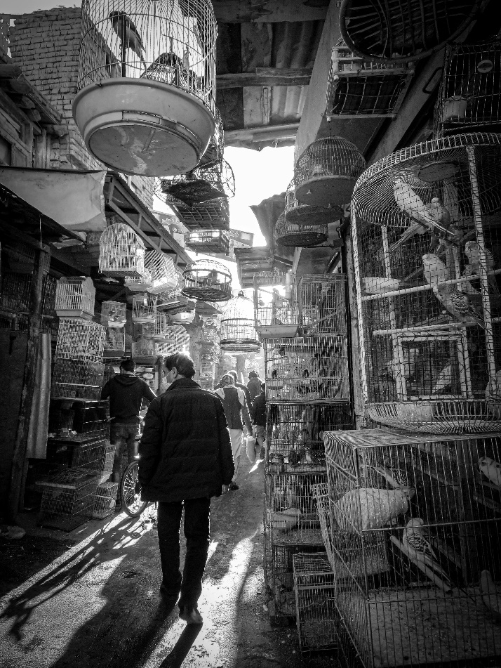
Article: Refugee Family Faces Challenges Adjusting to Life in New Zealand
Amina and her family recently arrived in New Zealand after fleeing Afghanistan to escape death threats from the Taliban. They were forced to leave behind their home, extended family, and careers, carrying only a few belongings and memories of a life they can never return to. Now, they face the daunting task of rebuilding their lives in a foreign land.
For Amina, a former school teacher, the language barrier has been her biggest challenge. “I want to continue teaching, but my English is not good enough yet,” she says. Her husband, Farid, struggles to find work as his qualifications are not recognized in New Zealand. Meanwhile, their teenage children, Layla and Hamid, are trying to fit in at school but feel isolated. Layla misses her friends in Afghanistan, and Hamid finds the New Zealand education system overwhelming.
The family’s situation highlights the complex experiences of acculturation. They are torn between maintaining their cultural identity and integrating into New Zealand society. Amina’s family exemplifies Berry’s Acculturation Model, which identifies four strategies people use to adjust to a new culture: integration, assimilation, separation, and marginalization.
Currently, the family seems to be leaning toward integration, as they try to maintain Afghan traditions at home while learning to navigate life in New Zealand. They participate in a local Afghan community group, where they find support and share cultural practices. However, Farid admits that it is difficult to balance both worlds. “Sometimes, it feels like we don’t fully belong anywhere,” he says.
The family’s experiences also reflect the challenges outlined in the Stress and Coping Framework of acculturation. Language barriers, unemployment, and social isolation are significant stressors. However, the family is finding ways to cope. Layla has joined a soccer team, which has helped her make friends, and Amina is attending English classes at a community center. They also receive support from a local refugee resettlement organization, which has helped them access housing and navigate the healthcare system.
While the journey ahead remains uncertain, Amina’s family is determined to build a new life. Their story illustrates both the struggles and resilience of refugees undergoing acculturation in a new country.

- Why did Amina’s family flee Afghanistan?
- What are some of the challenges Amina faces in New Zealand?
- Why can’t Farid find work in New Zealand?
- How are Layla and Hamid adjusting to their new school?
- What is the primary strategy of acculturation Amina’s family is using?
- Define integration in the context of Berry’s Acculturation Model.
- How does the Stress and Coping Framework explain the family’s experiences?
- What role does the local Afghan community group play in the family’s adjustment?
- How is Layla using soccer to cope with social isolation?
- What has Amina done to improve her English skills?
- Describe how the family is balancing Afghan traditions with New Zealand life.
- What challenges does the family face in maintaining their cultural identity?
- How does unemployment contribute to the family’s stress?
- What support is the family receiving from the refugee resettlement organization?
- Why does Farid feel like the family doesn’t fully belong anywhere?
- How might cultural differences between Afghanistan and New Zealand affect the family’s acculturation process?
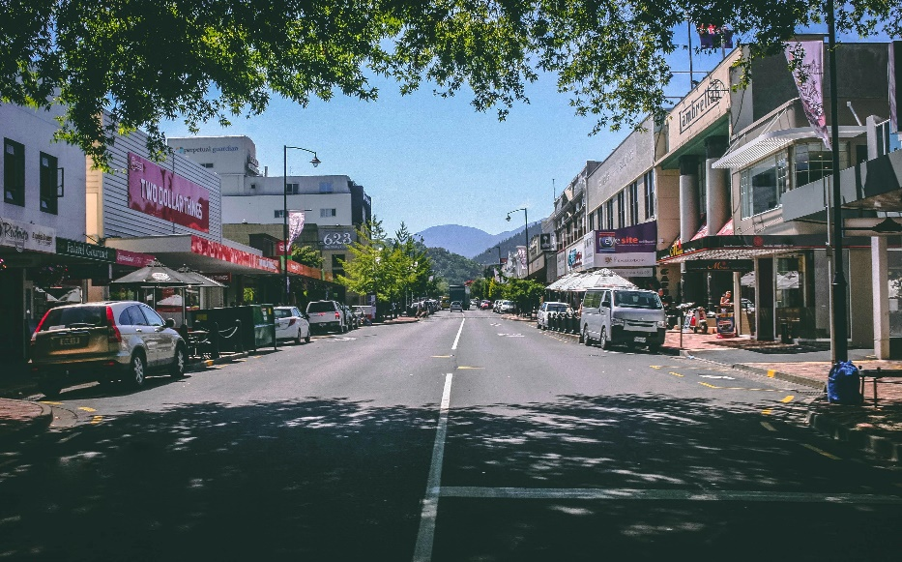
- What additional strategies could New Zealand communities implement to support refugee families?
- Do you think integration is the best strategy for Amina’s family? Why or why not?
- How might Layla and Hamid’s acculturation experiences differ from their parents’?
- Reflect on how Berry’s Acculturation Model applies to your own experiences or observations of cultural adaptation.

This worksheet is a free download from TomCoster[dot]com. Please support us by buying a copy of How to succeed at high school or college by Tom Coster – available on Amazon.

