Worksheet: Geert Hofstede’s Cultural Dimensions – Power Distance
Article: Understanding Power Distance in Global Cultures
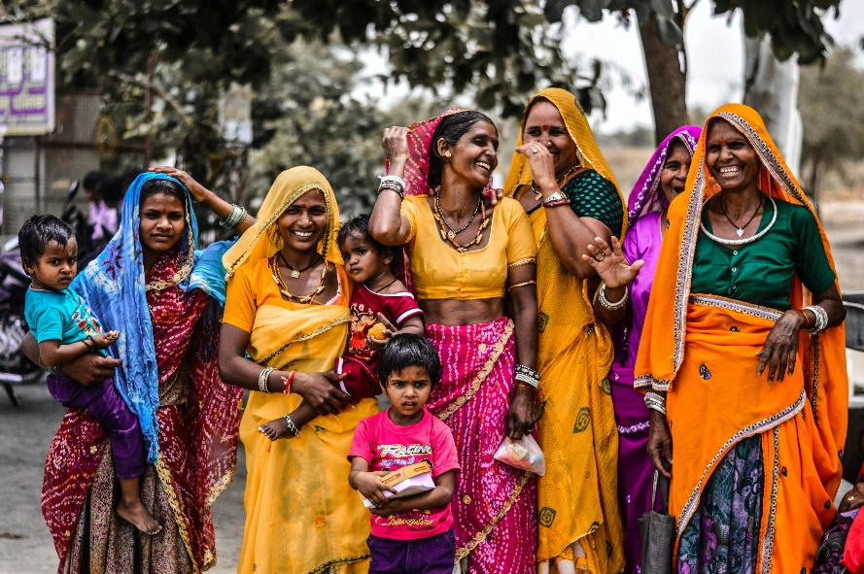
In the study of cultural differences, Geert Hofstede’s dimension of power distance offers valuable insights into how societies perceive and manage inequality. Power distance refers to the extent to which less powerful members of a society accept and expect that power is distributed unequally. Cultures with high power distance emphasize hierarchy and authority, while those with low power distance favor equality and participatory decision-making.
In high power-distance cultures, such as those in Malaysia, Russia, and many Middle Eastern countries, power dynamics are clearly defined. Subordinates often defer to their superiors without question, and decisions are typically centralized at the top. For example, in a high power-distance workplace, employees may hesitate to challenge their manager’s ideas, even if they disagree, because questioning authority is viewed as disrespectful.
Conversely, in low power-distance cultures like Denmark, New Zealand, and the Netherlands, flatter organizational structures are common. Here, employees are encouraged to share their opinions openly and may even address managers by their first names. Decision-making is more collaborative, and leaders are seen as equals rather than distant figures of authority.
Power distance is not only evident in workplaces but also in educational settings, family structures, and governance. In schools within high power-distance cultures, teachers are viewed as the ultimate authority, and students are less likely to question their guidance. In contrast, low power-distance classrooms often encourage debate and critical thinking, with students participating actively in the learning process.
Understanding power distance is crucial for effective cross-cultural communication. For instance, a manager from a low power-distance culture might mistakenly perceive a subordinate’s deference in a high power-distance culture as a lack of initiative, when in fact, it reflects respect for authority. Similarly, employees from high power-distance cultures might find the informality of a low power-distance workplace uncomfortable or even disrespectful.
It is important to note that power distance does not inherently determine the “right” or “wrong” way to structure a society. Both high and low power-distance cultures have strengths and challenges, depending on the context. By appreciating these differences, individuals can navigate cross-cultural interactions with greater understanding and effectiveness.
- What is power distance, and why is it important in cultural studies?
- How do high power-distance cultures view authority and hierarchy?
- Provide an example of how power distance might manifest in the workplace.
- What is a characteristic of low power-distance cultures in organizational settings?
- How might employees in high power-distance cultures respond to feedback from a manager?
- What are some examples of countries with high power distance?
- Name three countries known for their low power-distance cultures.
- How does power distance influence classroom dynamics in different cultures?
- Why might subordinates in high power-distance cultures hesitate to challenge authority?
- How does decision-making differ between high and low power-distance cultures?
- What might a low power-distance manager misunderstand about high power-distance employees?
- How does power distance affect the teacher-student relationship in schools?
- In what ways can power distance influence family structures?
- How might governance differ in high versus low power-distance societies?
- What role does cultural history play in shaping power distance within a society?
- How can understanding power distance improve communication in multinational organizations?
- Discuss a scenario where a high power-distance approach might be more effective than a low power-distance one.
- What challenges might arise when individuals from high and low power-distance cultures work together?
- Can a society’s power-distance orientation change over time? If so, what factors might drive this change?
- Reflect on your own cultural background. Where does it fall on the power-distance spectrum, and how has this influenced your personal or professional experiences?

This worksheet is a free download from TomCoster[dot]com. Please support us by buying a copy of How to succeed at high school or college by Tom Coster – available on Amazon.

