Worksheet: Understanding the Foot-in-the-Door Compliance Technique
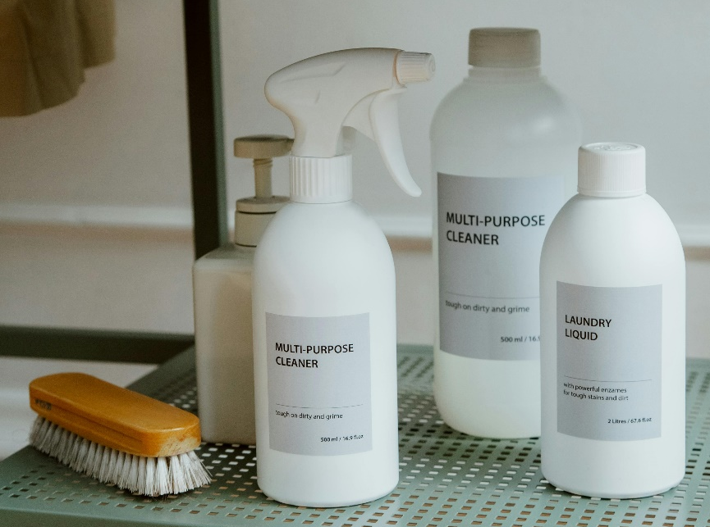
Salesman: Good afternoon! I’m John, and I’m with EcoClean Solutions. We’re doing a quick survey in the neighborhood to learn about people’s cleaning preferences. Would you mind answering a couple of short questions? It’ll only take two minutes.
Consumer: Uh, sure, I guess.
Salesman: Great! First question: How often do you clean your home—daily, weekly, or less often?
Consumer: Weekly, mostly.
Salesman: Thanks for that. And do you prefer chemical-based cleaners or eco-friendly ones?
Consumer: Eco-friendly, definitely. I try to avoid harsh chemicals.
Salesman: That’s excellent! It sounds like you care about both cleanliness and the environment. By the way, we’re running a free trial program where we provide a small bottle of our top eco-friendly cleaner for you to try. Would you like one?
Consumer: Sure, why not? It’s free, right?
Salesman: Absolutely free. I’ll drop it off later today. One last thing—many of our trial users find they love our products and want to continue using them. We offer a subscription service that delivers these cleaners to your home every month. Would you be interested in learning about that?
Consumer: Hmm, I guess I could hear more about it.
Salesman: Wonderful! Let me show you how easy it is to sign up. It’s a small commitment, and you can cancel anytime.
Consumer: Okay, let’s take a look.

- What is the foot-in-the-door technique?
- How does the salesman in the conversation use the foot-in-the-door technique?
- What is the psychological principle that makes the foot-in-the-door technique effective?
- Provide an example of the foot-in-the-door technique outside of sales.
- What is the difference between the foot-in-the-door technique and the door-in-the-face technique?
- Why does agreeing to a small request make someone more likely to agree to a larger one?
- How does the principle of consistency relate to compliance techniques?
- What role does trust play in the success of compliance techniques?
- Name two other compliance techniques besides foot-in-the-door.
- How might marketers use the foot-in-the-door technique in online advertising?
- Why is the initial request in the foot-in-the-door technique typically small?
- What is the importance of the second request being related to the first?
- How could the foot-in-the-door technique be ethically misused?
- How does timing between the first and second request affect the success of this technique?
- In what scenarios might the foot-in-the-door technique be less effective?
- Do you think the consumer in the conversation was aware of the compliance technique being used? Why or why not?
- How might cultural differences influence the effectiveness of the foot-in-the-door technique?
- Is it ethical for salespeople to use psychological principles like the foot-in-the-door technique to influence decisions? Why or why not?
- What strategies could consumers use to recognize and resist compliance techniques?
- Reflect on a time when you experienced or used the foot-in-the-door technique. How did it impact the outcome of the interaction?

This worksheet is a free download from TomCoster[dot]com. Please support us by buying a copy of How to succeed at high school or college by Tom Coster – available on Amazon.

