Worksheet: The Role of Social Learning Theory in Learning
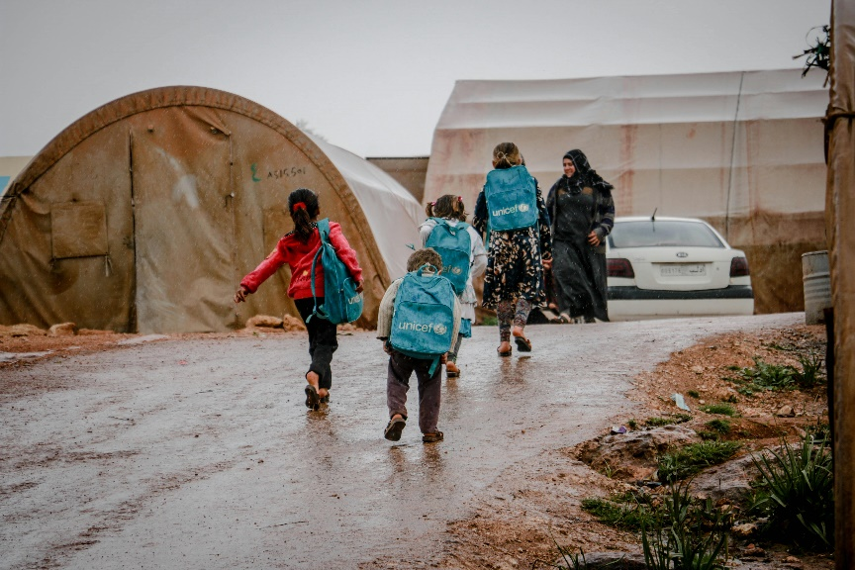
Article: Using Social Learning Theory to Help Refugees Adapt to a New Language and Culture. (Published in Cross-Cultural Education Today)
Social Learning Theory, developed by Albert Bandura, is a powerful framework for helping refugees learn the language and culture of their host country. This theory emphasizes that learning occurs through observation, imitation, and modeling, which makes it particularly effective in social and community-based settings. By creating environments where refugees can observe and interact with native speakers and cultural practices, host countries can accelerate the integration process.
Observation and Modeling in Language Learning
One of the most effective ways for refugees to learn a new language is by observing native speakers. Community centers and language classes often encourage this by integrating real-world simulations, such as mock grocery store visits or job interviews. Refugees watch instructors and volunteers model the language, including its pronunciation, grammar, and context. For example, a volunteer might demonstrate how to ask for directions, which refugees can then practice in a safe and supportive environment.
Peer Learning and Group Work
Refugees often find themselves in group settings where they can observe and learn from each other. For instance, language classes can pair beginners with more advanced learners, who serve as role models. This peer learning approach fosters confidence and encourages social bonding, as learners see firsthand how others navigate language and cultural challenges.
Cultural Assimilation Through Social Interaction
Beyond language, Social Learning Theory also helps refugees adapt to cultural norms and practices. By engaging in community events, volunteering, or shadowing native residents, refugees can observe behaviors such as greetings, gestures, and dining etiquette. For example, attending a local festival provides opportunities to learn about cultural traditions while practicing newly acquired language skills.
Motivation and Reinforcement
Motivation plays a critical role in the learning process. Refugees are more likely to imitate behaviors if they see positive outcomes. For instance, a refugee who successfully orders food in a local café might receive praise or a smile from the server, reinforcing the behavior. Similarly, community programs often celebrate small milestones, such as completing a language module, to keep learners motivated.
Creating Supportive Environments
A welcoming and supportive community is essential for Social Learning Theory to work effectively. Refugees need opportunities to observe and practice without fear of judgment. Programs that pair refugees with cultural ambassadors or language buddies help create a safe space for learning, making the process more effective and enjoyable.
By applying the principles of Social Learning Theory, host countries can create programs that not only teach language and culture but also empower refugees to build confidence and independence in their new environments. This approach highlights the importance of community engagement and the value of learning through observation and interaction.

- What is Social Learning Theory, and who developed it?
- How does observation play a role in language learning for refugees?
- What is the role of modeling in teaching refugees a new language?
- Provide an example of a real-world simulation used to teach language skills.
- How does peer learning benefit refugees in language classes?
- What are some cultural practices refugees can learn through observation?
- How can community events help refugees learn cultural norms?
- What role does motivation play in Social Learning Theory?
- What is an example of positive reinforcement in the article?
- Why is it important to create a supportive environment for learning?
- What is the significance of pairing refugees with cultural ambassadors?
- How can celebrating milestones help refugees stay motivated?
- What are the benefits of group work in language learning?
- Why is Social Learning Theory particularly effective for integration programs?
- How does Social Learning Theory go beyond language to include cultural adaptation?
- What challenges might refugees face when learning through observation and modeling?
- How can host countries ensure that Social Learning Theory is applied effectively in integration programs?
- What are the potential limitations of using Social Learning Theory in language and cultural adaptation?
- How might cultural differences between refugees and host communities affect the learning process?
- Reflect on a time when you learned something by observing others. How does that experience relate to Social Learning Theory?

This worksheet is a free download from TomCoster[dot]com. Please support us by buying a copy of How to succeed at high school or college by Tom Coster – available on Amazon.

