Worksheet: Factors that may explain differences in the prevalence of obesity between populations
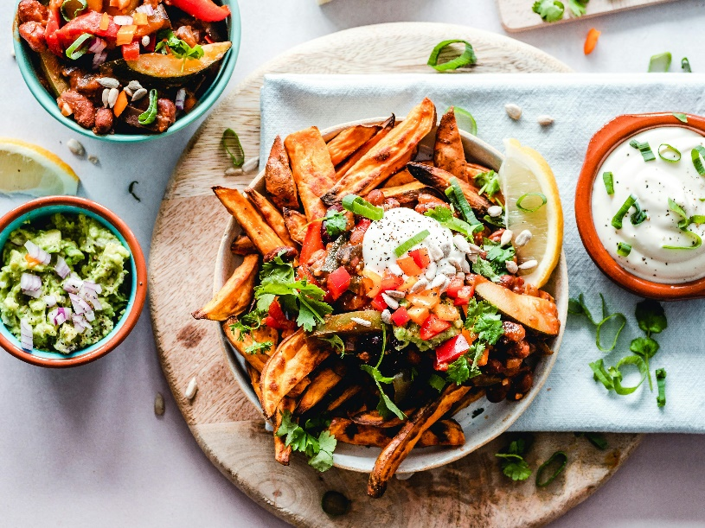
Dialogue: Two Students Discuss Obesity Trends
Emma: Hey Alex, have you ever wondered why obesity rates are so different across populations? It’s not just about individual choices, right?
Alex: Definitely not. There are so many factors involved. For example, genetics can play a big role. Some populations have genes that make them more efficient at storing fat, which might have been an advantage in the past when food was scarce. But now, with calorie-dense diets, it can lead to higher obesity rates.
Emma: That makes sense. But it’s not just biology. Cultural attitudes are a big factor too. In some societies, larger body sizes are associated with wealth or health, so there’s less pressure to stay thin. On the other hand, in cultures that idealize thinness, there’s more emphasis on healthy eating and exercise.
Alex: Right. Economic factors are also huge. In high-income countries, people often have access to cheap, processed foods that are high in calories but low in nutrition. At the same time, low-income populations within these countries might face food deserts, where it’s hard to find affordable, healthy food.
Emma: And urbanization plays a role too. In low-income countries, obesity rates are rising because people are adopting Western diets and becoming more sedentary as they move to cities. Urban environments often lack green spaces or safe areas for physical activity, which doesn’t help.
Alex: Plus, marketing and media exposure can’t be ignored. Kids especially are bombarded with ads for sugary snacks and fast food. This kind of early exposure creates habits that stick into adulthood.
Emma: That’s true. And let’s not forget about stress and mental health. Chronic stress, whether it’s from economic instability or systemic discrimination, can lead to emotional eating and weight gain. Some populations experience these stressors more intensely, which can explain higher obesity rates.
Alex: So, tackling obesity isn’t just about telling people to eat better and exercise more. It’s about addressing these broader systemic issues too.
Emma: Exactly. Public health policies like taxing sugary drinks, subsidizing healthy foods, and improving urban planning can make a big difference. But education campaigns tailored to different cultural and economic contexts are just as important.
Alex: Agreed. It’s such a complex issue, but understanding these factors is the first step toward meaningful solutions.
Emma: Thanks, Alex. This really helped me see the bigger picture.
Alex: Anytime, Emma. It’s fascinating how interconnected everything is.

- How do genetic factors contribute to differences in obesity rates between populations?
- Why might larger body sizes be considered desirable in some cultures?
- How do cultural attitudes toward thinness impact obesity prevalence?
- What role do processed foods play in high-income countries’ obesity rates?
- What is a food desert, and how does it affect low-income populations?
- How has urbanization influenced obesity rates in low-income countries?
- Why are green spaces important for reducing obesity rates?
- How does marketing influence childhood obesity?
- What differences exist between countries with and without strict food advertising regulations?
- How does chronic stress contribute to emotional eating and obesity?
- How do systemic discrimination and economic instability impact obesity rates?
- What is the relationship between early exposure to fast food ads and lifelong eating habits?
- How can public health policies address food accessibility issues?
- Why is it important to consider cultural attitudes in obesity prevention strategies?
- How can urban planning promote healthier lifestyles?
- Discuss the ethical implications of targeting children in fast food advertising.
- How might globalization change cultural perceptions of body size and obesity?
- What challenges might arise when implementing subsidies for healthy foods in low-income areas?
- How can education campaigns address both cultural and socioeconomic factors influencing obesity?
- Reflect on how your own local environment supports or hinders healthy lifestyle choices.

This worksheet is a free download from TomCoster[dot]com. Please support us by buying a copy of How to succeed at high school or college by Tom Coster – available on Amazon.

