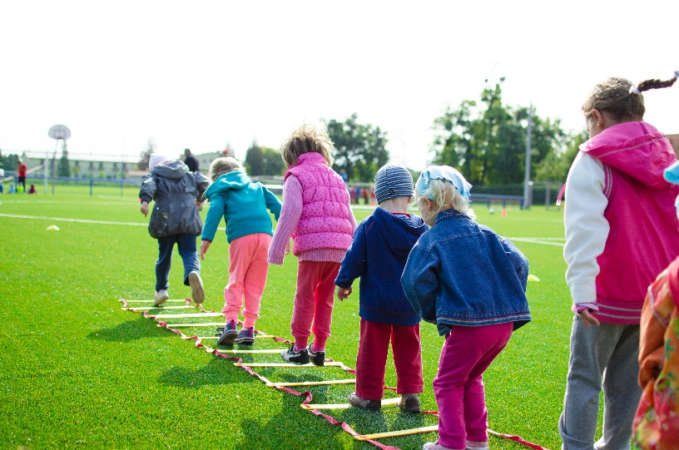
Worksheet: Factors that may explain changes in the prevalence of obesity in a population
Dialogue: Two Students Discuss Obesity Trends
Alex: Hey Mia, I’m trying to make sense of why obesity rates keep rising in some populations. It seems like such a complex issue.
Mia: It definitely is, but it’s fascinating too. A big part of it comes down to changes in our environment. For example, the availability of calorie-dense, processed foods has skyrocketed. These foods are cheaper and more accessible than fresh fruits and vegetables.
Alex: That makes sense. I read somewhere that portion sizes have also increased over the years. It’s like overeating has become the norm.
Mia: Exactly. And it’s not just about food. Our lifestyles have changed a lot too. Sedentary behaviors, like spending hours in front of screens or driving everywhere instead of walking, have become much more common. This lack of physical activity contributes to the imbalance between calories in and calories out.
Alex: So, it’s a mix of what we eat and how we live. But what about stress? I’ve heard that stress can lead to weight gain.
Mia: That’s a great point. Stress is a major psychological factor. When people are stressed, they often turn to comfort foods, which are usually high in sugar and fat. Chronic stress can also mess with hormones like cortisol, which might encourage the body to store fat.
Alex: What about kids? Why are childhood obesity rates climbing?
Mia: A lot of it comes down to marketing. Kids are constantly exposed to ads for unhealthy snacks and fast food. Combine that with less outdoor play and more screen time, and it’s a recipe for rising obesity rates in younger populations.
Alex: That’s so true. But I guess cultural factors play a role too, right?
Mia: Absolutely. In some cultures, larger body sizes are seen as a sign of prosperity or health, so there’s less pressure to stay thin. In others, obesity is stigmatized, which can actually discourage people from seeking help or exercising in public.
Alex: And what about economic factors? Do things like poverty and food deserts make a difference?
Mia: Definitely. Low-income communities often lack access to affordable, healthy food options. They might also have fewer safe spaces for exercise. Economic instability can create a cycle where people rely on cheap, unhealthy food because it’s all they can afford.
Alex: So, tackling obesity isn’t just about personal responsibility. It’s about addressing these broader systems too.
Mia: Exactly. Public health policies, like taxes on sugary drinks or programs that make fresh produce more accessible, are crucial. Education campaigns can also help people make better choices, but systemic change is key.
Alex: Thanks, Mia. That really clears things up!
Mia: Anytime, Alex. It’s a complex issue, but understanding it is the first step to solving it.

- What role do calorie-dense foods play in rising obesity rates?
- How have portion sizes changed over time, and why does this matter?
- What are some examples of sedentary behaviors contributing to obesity?
- How does stress influence eating habits and weight gain?
- What is the impact of marketing unhealthy foods on children?
- Why might childhood obesity rates be increasing?
- How do cultural attitudes toward body size vary, and how do they impact obesity rates?
- What challenges do low-income communities face in accessing healthy food?
- How do food deserts contribute to obesity?
- Why is physical activity important in preventing obesity?
- How can chronic stress affect the body’s metabolism?
- What role does economic instability play in shaping dietary habits?
- How do stigmatizing attitudes toward obesity affect individuals’ willingness to seek help?
- What systemic barriers exist to maintaining a healthy lifestyle?
- How can public health policies help reduce obesity prevalence?
- Discuss how cultural perceptions of body size might evolve over time and impact obesity rates.
- What ethical considerations arise when marketing unhealthy foods to vulnerable populations like children?
- How could governments effectively address the issue of food deserts?
- Why is it important to focus on systemic changes rather than solely on individual responsibility in tackling obesity?
- Reflect on how public health campaigns could be tailored to address both cultural and socioeconomic factors influencing obesity.
This worksheet is a free download from TomCoster[dot]com. Please support us by buying a copy of How to succeed at high school or college by Tom Coster – available on Amazon.

