Worksheet: Cultural and Population Differences in Prevalence Rates of Major Depressive Disorder
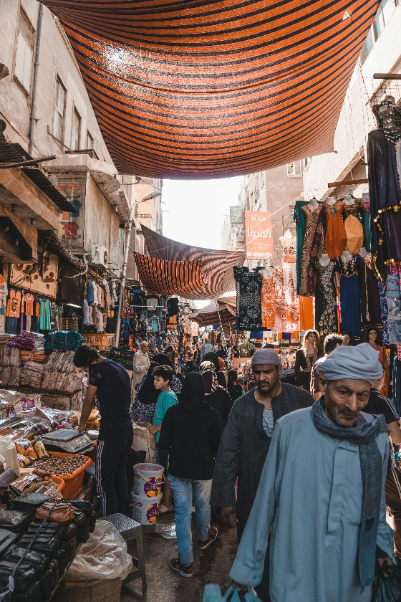
Article: Why Depression Rates Differ Across Cultures and Populations
Major Depressive Disorder (MDD) is a global mental health challenge, yet its prevalence varies significantly between cultures and populations. Understanding these differences requires examining a combination of biological, social, and cultural factors.
One explanation lies in genetic predispositions. Studies show that genetic variations linked to depression can differ among populations. For example, certain genetic markers associated with serotonin regulation may be more or less prevalent in specific ethnic groups, potentially influencing the risk of developing MDD. However, genetics alone cannot account for the wide disparities observed worldwide.
Cultural attitudes toward mental health also play a significant role. In some cultures, there is a stigma surrounding mental illness, which may discourage individuals from seeking help or reporting symptoms. For instance, collectivist societies often emphasize group harmony and may downplay personal struggles, leading to underreporting of depressive symptoms. In contrast, individualistic cultures might encourage openness about personal challenges, resulting in higher reported prevalence rates.
Socioeconomic factors are another crucial consideration. Poverty, unemployment, and lack of access to healthcare are strongly associated with increased rates of depression. Populations facing chronic stress due to economic instability or systemic discrimination are at higher risk. For example, studies have shown that marginalized groups, such as refugees or ethnic minorities, often experience higher rates of MDD due to the stress of acculturation and discrimination.
Environmental factors, such as exposure to natural disasters or conflict, also contribute to variations in depression rates. Populations living in regions affected by war or frequent natural disasters are more likely to experience trauma, which can lead to higher rates of depression. Similarly, urbanization and social isolation in densely populated cities can exacerbate feelings of loneliness, contributing to higher rates of MDD.
Additionally, diagnostic criteria and tools may influence reported prevalence rates. Western diagnostic frameworks, such as the DSM, may not fully capture how depression manifests in non-Western cultures. For example, in some Asian cultures, individuals with depression might report primarily physical symptoms, such as fatigue or headaches, rather than emotional symptoms like sadness or hopelessness.
In summary, the differences in prevalence rates for MDD between cultures and populations result from a complex interplay of genetic, cultural, socioeconomic, and environmental factors. Recognizing these influences is essential for developing culturally sensitive diagnostic tools and interventions that address the unique needs of diverse populations.

- What is Major Depressive Disorder (MDD)?
- How do genetic factors influence the prevalence of MDD in different populations?
- Why might cultural attitudes toward mental health affect reporting rates for depression?
- How does stigma surrounding mental illness vary between collectivist and individualistic cultures?
- What socioeconomic factors are associated with higher rates of depression?
- How does poverty contribute to the risk of developing MDD?
- Why are marginalized groups at higher risk for MDD?
- What environmental factors can increase the prevalence of depression in certain populations?
- How might living in a war-torn region affect rates of MDD?
- Why are urbanization and social isolation linked to higher depression rates?
- What role do diagnostic criteria play in measuring depression prevalence?
- How might Western diagnostic frameworks fail to capture depression in non-Western cultures?
- Provide an example of how depression symptoms might differ in Asian cultures.
- What is the impact of natural disasters on mental health in affected populations?
- Why is it important to develop culturally sensitive diagnostic tools for MDD?
- How could cultural stigma around mental health be reduced to improve reporting and treatment of MDD?
- What are the ethical considerations in applying Western diagnostic frameworks to non-Western populations?
- How might socioeconomic policies address the prevalence of depression in marginalized groups?
- Discuss how globalization might influence cultural attitudes toward mental health and depression.
- Reflect on how your own cultural background might shape your understanding and experience of depression.

This worksheet is a free download from TomCoster[dot]com. Please support us by buying a copy of How to succeed at high school or college by Tom Coster – available on Amazon.

