Worksheet: Worksheet: Understanding Data Distribution in Psychology
Lecture: A Psychology Teacher Explains Data Distribution
Teacher: Good morning, class. Today, we’ll discuss data distribution, an essential concept in psychology research. Understanding how data is distributed helps us analyze results and draw meaningful conclusions about behavior and mental processes.
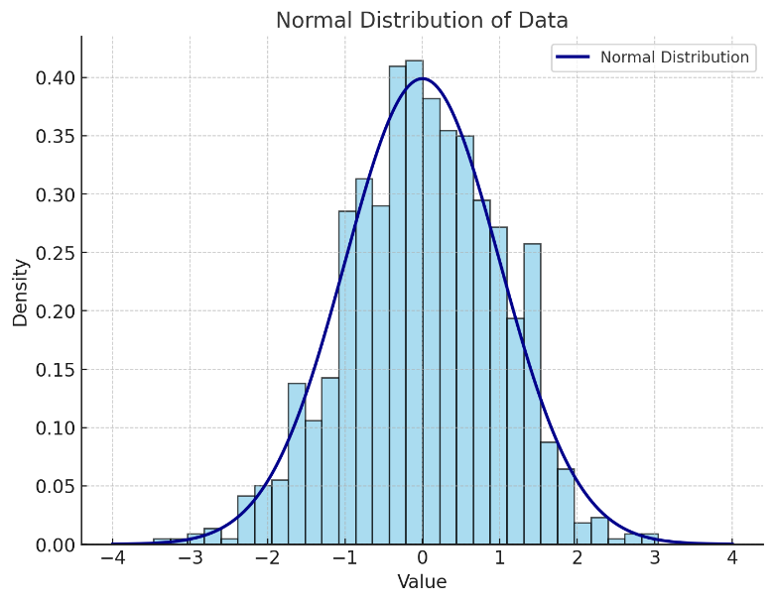
One common type of data distribution is the normal distribution, often called the "bell curve." It’s symmetric, with most data clustering around the mean, and the tails representing fewer extreme values. A good example might be IQ scores, which typically form a normal distribution in the population.
A normal distribution of data
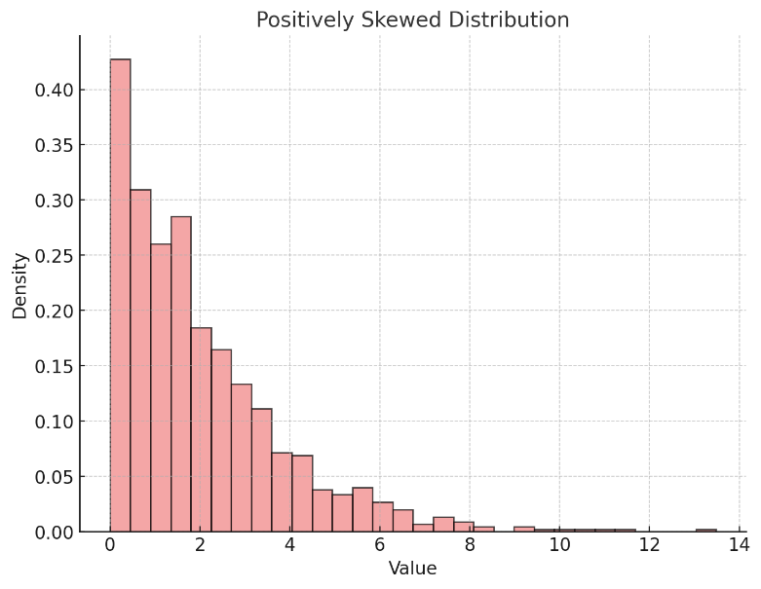
Sometimes, however, data doesn’t follow this pattern. Skewed distributions occur when data points pile up on one side of the graph. In a positively skewed distribution, the tail extends to the right, indicating a concentration of lower scores. For example, income levels in a population often show positive skew because a few people earn significantly more than the rest. Conversely, a negatively skewed distribution has a tail that extends to the left, reflecting a concentration of higher scores.
A skewed distribution of data
Another important concept is kurtosis, which describes the "peakedness" of a distribution. Distributions with high kurtosis have a sharper peak, while those with low kurtosis are flatter.
Understanding data distribution also helps us determine whether to use specific statistical tests. Many tests, like the t-test, assume a normal distribution. When the data doesn’t meet these assumptions, researchers often use non-parametric tests, which are less sensitive to distribution.
Finally, let’s not forget outliers—data points far removed from others. Outliers can distort the mean, making it less representative. For example, in a study on reaction times, a single extremely slow participant could shift the average significantly.
To analyze data distribution, psychologists often use histograms, box plots, or descriptive statistics like skewness and kurtosis values. Software tools like SPSS or Excel are commonly used to visualize and interpret these patterns.
Understanding data distribution allows us to recognize trends, identify anomalies, and apply the appropriate statistical methods. It’s a critical skill for interpreting psychological research accurately.

- What is a normal distribution, and why is it called a bell curve?
- How are data points distributed in a normal distribution?
- What does it mean when a distribution is positively skewed?
- Provide an example of a positively skewed distribution in real-life data.
- What does it mean when a distribution is negatively skewed?
- What is kurtosis, and what does it measure in a distribution?
- How does high kurtosis differ from low kurtosis in a dataset?
- Why are outliers important to consider when analyzing data distribution?
- How can outliers affect the mean of a dataset?
- What types of graphs are useful for visualizing data distribution?
- What is the relationship between data distribution and statistical tests?
- Why might researchers use non-parametric tests in some studies?
- What does the tail of a skewed distribution represent?
- How do histograms help us understand data distribution?
- What role does software like SPSS or Excel play in analyzing data distribution?
- Why might data from psychological studies often show skewed rather than normal distributions?
- How could failing to account for outliers affect the conclusions of a psychological study?
- If you were conducting a study with highly skewed data, how would you ensure your analysis was accurate?
- Why might kurtosis be a useful measure in psychological research?
- Discuss how understanding data distribution could help psychologists make better-informed decisions in clinical practice.

This worksheet is a free download from TomCoster[dot]com. Please support us by buying a copy of How to succeed at high school or college by Tom Coster – available on Amazon.

