Worksheet: The Role of Childhood Experiences in the Development of Self
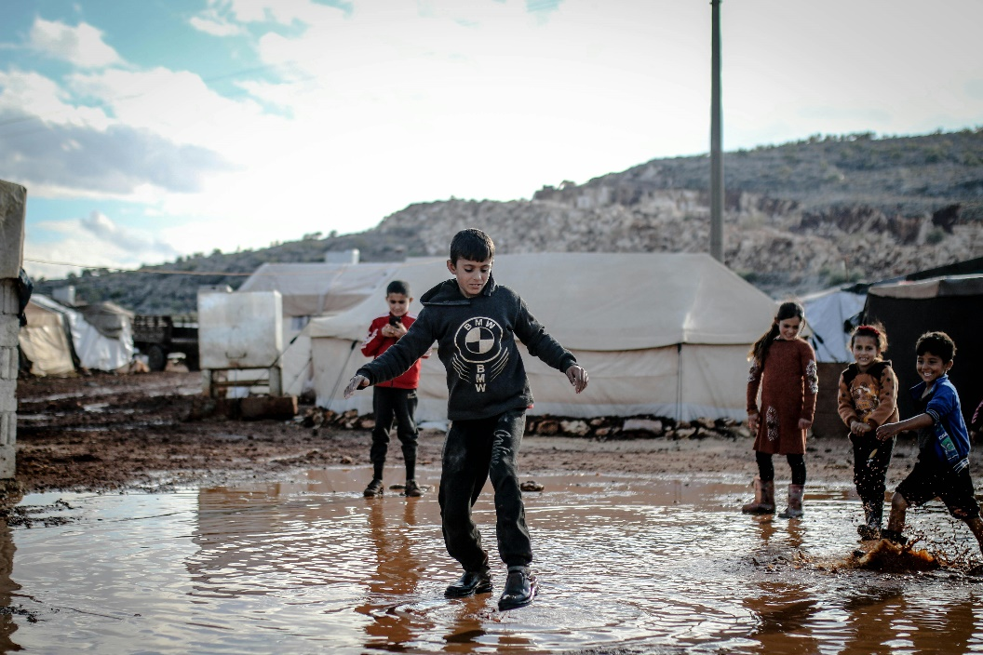
Lecture: A Psychology Professor Discusses Childhood Experiences in Refugee Camps
Professor Carter: Good morning, class. Today, we’ll discuss how childhood experiences in refugee camps impact the development of self. Growing up in a refugee camp is a unique and challenging experience, marked by instability, limited resources, and exposure to trauma. These conditions profoundly shape a child’s identity, self-concept, and emotional well-being.
One of the most significant factors influencing self-development in refugee camps is the lack of stability. Frequent displacement, uncertainty about the future, and limited access to education disrupt a child’s sense of security. Without stability, children may struggle to form a coherent sense of self, as their environments do not provide consistent opportunities for growth and exploration.
Social interactions also play a critical role. In refugee camps, children are often part of tightly knit communities that rely on collective resilience. While this can foster a sense of belonging and shared identity, it may also limit individual expression. Cultural and social norms within the camp can heavily influence how children view themselves and their roles within the group.
Trauma is another pervasive factor. Many children in refugee camps have witnessed or experienced violence, loss, and separation from loved ones. These experiences can lead to feelings of fear, guilt, or helplessness, which significantly impact self-esteem and emotional regulation. Trauma can also interfere with cognitive and social development, making it harder for children to form positive self-concepts.
However, resilience is a remarkable aspect of human development. Despite these challenges, many children in refugee camps demonstrate incredible adaptability and strength. Supportive relationships, even in adverse conditions, can mitigate the negative effects of trauma. Teachers, caregivers, and peers within the camp can provide emotional support and validation, helping children build a sense of worth and belonging.
Access to education is a crucial factor in shaping self-development in refugee camps. Schools provide not only academic learning but also a sense of normalcy and routine. They offer a space where children can develop skills, gain confidence, and envision a better future. Educational programs that address the specific needs of refugee children, such as trauma-informed teaching, can play a transformative role.
In conclusion, growing up in a refugee camp presents significant challenges to the development of self. However, the presence of supportive relationships, access to education, and community resilience can help mitigate these effects. By understanding the unique experiences of these children, we can create interventions and policies that support their growth and well-being.

- How do unstable conditions in refugee camps affect a child’s self-concept?
- What challenges do children in refugee camps face in forming a sense of security?
- How can tightly knit communities in refugee camps influence self-development?
- What role do social norms in refugee camps play in shaping a child’s identity?
- How does exposure to trauma impact a child’s emotional well-being?
- What are some cognitive effects of experiencing trauma in childhood?
- How can supportive relationships help children in refugee camps build resilience?
- What is the significance of education for children in refugee camps?
- How do schools provide a sense of normalcy for children in refugee camps?
- What specific teaching approaches can support refugee children’s needs?
- Why is stability important for a child’s self-development?
- What role do caregivers play in supporting children’s emotional needs in refugee camps?
- How can peers contribute to resilience in refugee camps?
- What are some barriers to education that children in refugee camps face?
- How does collective resilience manifest in refugee camp communities?
- How might cultural differences influence the experiences of children in refugee camps?
- What strategies could be used to address the trauma experienced by refugee children?
- Discuss how access to education in refugee camps might shape long-term outcomes for children.
- How can international organizations better support the self-development of children in refugee camps?
- Reflect on how growing up in a refugee camp might influence an individual’s identity and values as an adult.

This worksheet is a free download from TomCoster[dot]com. Please support us by buying a copy of How to succeed at high school or college by Tom Coster – available on Amazon.

