Worksheet: Descriptive Statistics – Measures of Dispersion
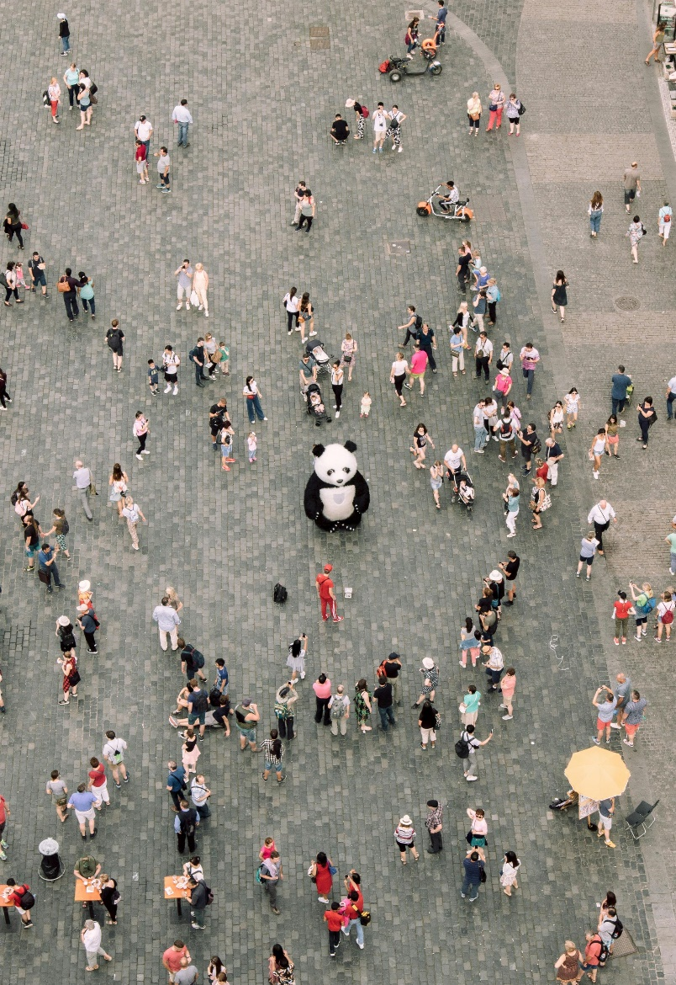
In psychology, descriptive statistics are used to summarize and analyze data. Measures of dispersion help us understand the variability or spread of data points in a dataset. Three key measures of dispersion are:
- Range: The difference between the highest and lowest values in the dataset. It provides a simple measure of variability but is sensitive to outliers.
- Interquartile Range (IQR): The range of the middle 50% of the data, calculated by subtracting the first quartile (Q1) from the third quartile (Q3). IQR is less affected by outliers and is useful for skewed datasets.
- Standard Deviation (SD): The average distance of data points from the mean. It provides a more precise measure of variability and is best used for normally distributed data.
Example: Stress Levels of Participants
A psychologist measures the stress levels (on a scale of 1 to 10) of 12 participants in a mindfulness program. The data is: Stress Levels: 3, 4, 5, 5, 6, 6, 6, 7, 8, 8, 9, 10
- What is the range of the stress levels in the dataset?
- How do you calculate the interquartile range (IQR) for this dataset?
- What is the IQR of the dataset?
- Why is the IQR less affected by outliers compared to the range?
- What does the standard deviation tell us about the dataset?
- How would a higher standard deviation affect the interpretation of the data?
- What does a small standard deviation indicate about the dataset?
- If the stress level of one participant increased to 15, how would the range change?
- How would the IQR be affected by the outlier in Question 8?
- Why is the standard deviation considered more precise than the range?
- In what situations is the range the most appropriate measure of dispersion?
- Why might a psychologist choose to use the IQR for analyzing a skewed dataset?
- What additional information does the standard deviation provide compared to the mean alone?
- How does the shape of the data distribution influence the choice of a measure of dispersion?
- Why is it important to use measures of dispersion alongside measures of central tendency?
- What are the limitations of using only the range to describe variability?
- How might cultural differences or environmental factors influence the variability of stress levels in a dataset?
- If two datasets have the same mean but different standard deviations, what does that tell you about the datasets?
- What strategies could a psychologist use to handle outliers when calculating measures of dispersion?
- Reflect on a dataset you’ve encountered. How did variability influence the conclusions drawn from the data?
- A psychologist collects data on the number of hours teenagers spend on social media per day over a week. The data is: Hours: 2, 3, 3, 4, 5, 8, 10
- Calculate the range of the dataset.
- Find the IQR of the dataset.
- What is the standard deviation of the dataset (rounded to 2 decimal places)?
- How does the outlier (10 hours) affect the range, IQR, and standard deviation?
- Which measure of dispersion best represents this dataset? Why?

This worksheet is a free download from TomCoster[dot]com. Please support us by buying a copy of How to succeed at high school or college by Tom Coster – available on Amazon.

