Worksheet: Analyzing and Interpreting Data Tables
Data tables, such as frequency tables, are tools used to organize and summarize data, making it easier to identify patterns and trends. Frequency tables specifically show how often each value or category occurs in a dataset. Interpreting these tables is a key skill in psychology, as they are often used to summarize research findings and analyze patterns in behavior or responses.
Example Frequency Table
The table below summarizes responses from a survey where 100 participants rated their satisfaction with a new therapy program on a scale from 1 (very dissatisfied) to 5 (very satisfied).
Satisfaction Rating | Frequency | Percentage
1 (Very Dissatisfied) | 5 | 5%
2 | 10 | 10%
3 | 20 | 20%
4 | 35 | 35%
5 (Very Satisfied) | 30 | 30%

Questions
Interpreting the Example Frequency Table
- How many participants rated their satisfaction as "5 (Very Satisfied)"?
- What percentage of participants were "Very Dissatisfied"?
- What satisfaction rating was the most common?
- What is the total number of participants who rated their satisfaction as "3" or "4"?
- What percentage of participants gave a rating of "3 or lower"?
Analyzing Trends and Patterns
- Based on the data, is the overall satisfaction with the therapy program high or low? Explain your reasoning.
- What might the distribution of ratings suggest about the effectiveness of the therapy program?
- If you were to graph this data, what type of graph would best represent the frequency distribution?
- What additional information might be useful to understand the context of this data?
- How could researchers use this table to improve the therapy program?
Critical Thinking Questions
- What are some advantages of using frequency tables to summarize survey results?
- What are some limitations of frequency tables when interpreting complex datasets?
- How might this data differ if the sample size were larger?
- If satisfaction levels decreased over time, how might the frequency table change?
- What factors could influence participants’ satisfaction ratings, and how could these be measured in future research?

Practice Activity: Analyze Another Frequency Table
Below is a frequency table showing the number of hours students reported studying for an exam.
Hours Studied | Frequency | Percentage
0–2 Hours | 12 | 12%
3–5 Hours | 28 | 28%
6–8 Hours | 35 | 35%
9–11 Hours | 15 | 15%
12+ Hours | 10 | 10%

- What is the most common range of hours studied?
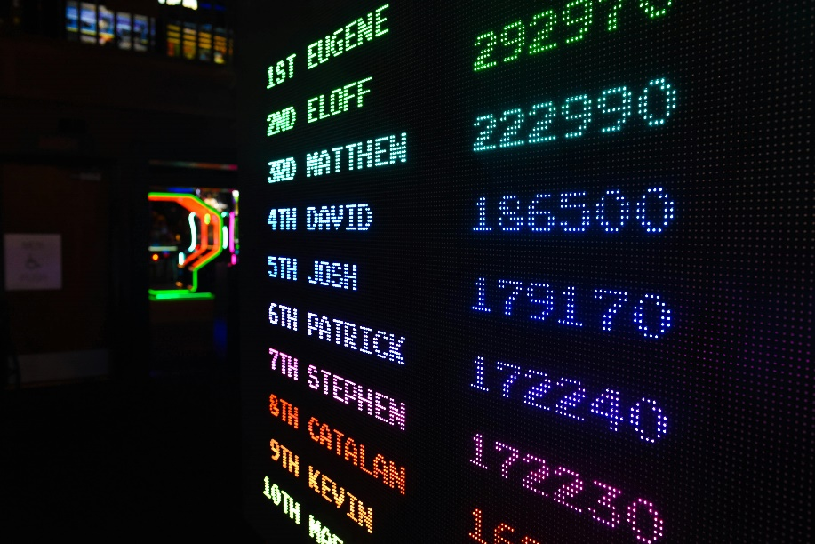
- What percentage of students studied for more than 8 hours?
- How many students studied for 5 hours or less?
- If the total number of students surveyed is 100, what percentage studied between 6 and 11 hours?
- What conclusions can you draw about study habits based on this data?

This worksheet is a free download from TomCoster[dot]com. Please support us by buying a copy of How to succeed at high school or college by Tom Coster – available on Amazon.

