Worksheet: The Role of One Cultural Factor in One Cognitive Process
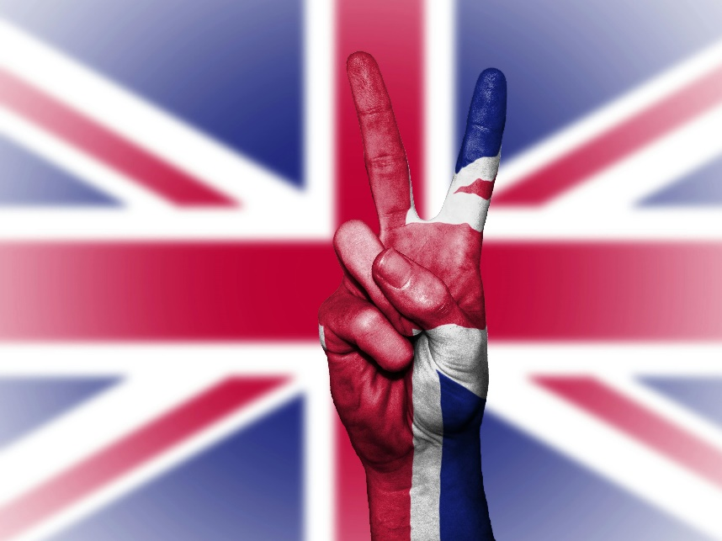
‘The Role of Culture in the Process of Reconstructing Memories’ by Dr. Eleanor Banks, Visiting Psychology Professor
Good afternoon, everyone. Today, I want to explore how culture influences one of our key cognitive processes: memory. To do this, we’ll look closely at a famous study conducted by Sir Frederic Bartlett in 1932, known as The War of the Ghosts. This study highlights how culture shapes the way we recall and reconstruct memories.
Memory is not a perfect recording of events. Instead, it is a reconstructive process. Bartlett demonstrated this by asking participants from the United Kingdom to read a Native American folk tale, The War of the Ghosts. The story was unfamiliar to them in structure, content, and themes because it came from a culture very different from their own. After reading, participants were asked to recall the story multiple times over weeks and months.
What Bartlett found was fascinating. As participants recalled the story, they unintentionally altered it to make it more consistent with their own cultural framework. For example, unfamiliar elements, such as references to ghosts or spiritual themes, were either omitted or transformed to fit Western norms. Words and phrases were changed, and certain details were added to align the story more closely with the participants’ cultural expectations. Bartlett referred to this process as "effort after meaning", where people modify information to make it more comprehensible within their cultural context.
This study illustrates how memory reconstruction is influenced by schemas, which are mental frameworks shaped by cultural experiences. UK participants had schemas based on their Western upbringing, which differed significantly from the cultural context of the Native American story. Their cultural schemas filled in gaps or adjusted inconsistencies in the story, often unconsciously.
Bartlett’s findings are significant because they challenge the idea that memory is a straightforward process of retrieval. Instead, memory is dynamic and subject to distortion, especially when the information conflicts with existing schemas. This has profound implications for understanding how culture influences not just memory but other cognitive processes, like perception and decision-making.
One real-world implication of Bartlett’s work lies in eyewitness testimony. Cultural biases can shape how events are remembered and retold, leading to distortions that affect the accuracy of testimony. Similarly, in education, students from diverse cultural backgrounds may interpret the same material differently due to variations in schemas.
However, Bartlett’s study has its limitations. For instance, his methodology wasn’t as rigorous as modern standards require. There were no standardized procedures for how participants recalled the story, and some argue that his findings lack generalizability. Still, his research laid the foundation for the study of cultural influences on cognition.
In conclusion, Bartlett’s The War of the Ghosts study reveals how culture shapes the reconstructive nature of memory. By understanding these influences, we can better appreciate the complex interplay between cognition and cultural context.

- Who conducted the study known as The War of the Ghosts?
- What type of story did Bartlett use in his study?
- Why was the Native American folk tale unfamiliar to Bartlett’s participants?
- What process did Bartlett observe when participants recalled the story?
- What is "effort after meaning," and how does it relate to Bartlett’s study?
- How did participants alter the story during recall?
- What role do schemas play in memory reconstruction?
- How were the participants’ cultural schemas different from those in the Native American story?
- What does Bartlett’s study suggest about the reliability of memory?
- What cultural biases did Bartlett observe in the participants’ retelling of the story?
- Why is Bartlett’s study important for understanding eyewitness testimony?
- How can culture influence other cognitive processes, like perception?
- What are some examples of how culture affects schemas?
- What were some limitations of Bartlett’s methodology?
- How does Bartlett’s work contribute to the field of cognitive psychology?
- How might the results of Bartlett’s study differ if conducted with participants from another culture?
- What steps could researchers take to minimize cultural bias in memory studies?
- How might "effort after meaning" influence how history is remembered and retold?
- Do you think Bartlett’s findings apply to modern multicultural societies? Why or why not?
- Reflect on your own experiences. Can you think of a time when your cultural background influenced how you remembered or interpreted an event?

This worksheet is a free download from TomCoster[dot]com. Please support us by buying a copy of How to succeed at high school or college by Tom Coster – available on Amazon.

