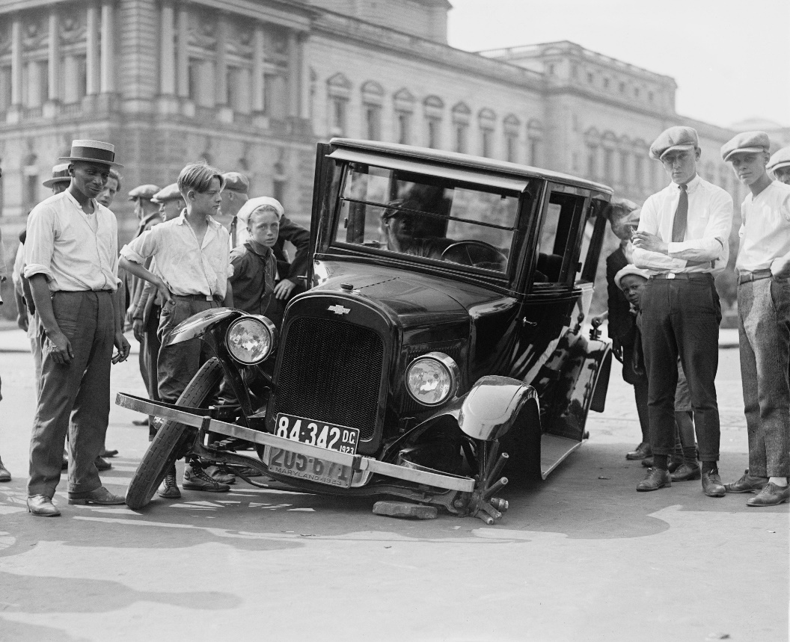
Worksheet: Identifying Bias in a News Article about Electric/Self-Driving Car Crashes
Objective: To identify and describe the availability bias in a news article and understand how it can influence our perception of risk.
Instructions: Read the following short news article about electric/self-driving car crashes. Afterward, answer the questions to identify and describe the availability bias in the way the article is written and how it may shape people’s attitudes toward self-driving technology.

News article: Self-Driving Cars Involved in 30% More Crashes in 2024
In 2024, self-driving cars have been linked to a 30% increase in traffic accidents compared to previous years. Despite advancements in technology, experts have raised concerns over the reliability of these vehicles. The National Traffic Safety Administration (NHTSA) has reported that while the majority of these accidents were minor, there have been several high-profile incidents where fully autonomous vehicles failed to respond to sudden obstacles or unexpected road conditions.
Critics argue that the rapid adoption of self-driving cars is happening too quickly, with insufficient testing on real-world roads. This has led many to question the safety of autonomous vehicles, fearing they may be less reliable than human drivers. While proponents of the technology insist that self-driving cars have the potential to reduce human error and make roads safer in the long run, recent crashes are fueling skepticism among the public.

Questions:
- What is the availability bias in this article? Identify how the article might cause readers to perceive self-driving cars based on the incidents mentioned.
- How does the article emphasize certain crashes while downplaying the broader context or other factors involved? What effect might this have on readers' understanding of self-driving car safety?
- What assumptions can be made about the public's perception of self-driving cars based on the tone and content of the article? How might this contribute to the availability bias?
- Can you think of any other instances where the availability bias might shape how we perceive a certain technology, event, or trend? Provide an example and explain how the bias works in that context.

Reflection:
- After identifying the availability bias in this article, reflect on how the media can influence public opinion and decision-making. How can we counteract the availability bias to make more informed choices?

This worksheet is a free download from TomCoster[dot]com. Please support us by buying a copy of How to succeed at high school or college by Tom Coster – available on Amazon.

