Worksheet: Exploring Schema Theory through Bartlett’s War of the Ghosts Study
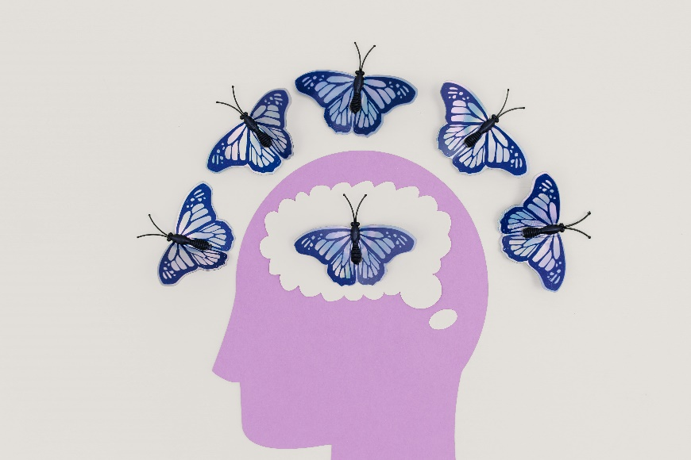
Ella: Hey, Liam, I’m trying to wrap my head around this whole schema theory thing. Our professor mentioned Bartlett’s "War of the Ghosts" study as a key example, but I’m struggling to connect the dots. Can you help?
Liam: Sure, Ella! So, schema theory is all about how our preexisting knowledge frameworks—schemas—affect the way we process, store, and recall information. Bartlett’s study shows this really well.
Ella: Okay, so what exactly did Bartlett do in the study?
Liam: Bartlett gave participants a Native American folk story called "The War of the Ghosts" to read. The story had unfamiliar cultural elements for most of the participants, who were from the UK. After reading it, they were asked to recall the story multiple times over days, weeks, or even months.
Ella: And how does that connect to schema theory?
Liam: Well, Bartlett found that participants’ recollections of the story changed over time. They tended to omit details that didn’t fit their cultural schemas or replace them with details that made more sense to them. For instance, they often changed "canoe" to "boat" and "hunting seals" to "fishing."
Ella: So their schemas influenced how they remembered the story?
Liam: Exactly. Their memories were reconstructed based on their own cultural expectations and knowledge. Bartlett called this process "effort after meaning," where people try to make sense of new information using what they already know.
Ella: That’s interesting. But does it mean their memories were completely wrong?
Liam: Not entirely. Their memories were consistent with their schemas, but they weren’t accurate reflections of the original story. Bartlett’s study shows that memory isn’t like a video recorder. It’s influenced by our prior experiences and cultural background.
Ella: So, schema theory explains why people’s memories might differ for the same event?
Liam: Exactly. It’s why eyewitnesses can have different recollections of the same event. Their schemas shape what they focus on and how they interpret and remember the details.
Ella: That makes sense now. Thanks, Liam. Schema theory really highlights how subjective memory can be.
Liam: It does. And understanding it can help us be more critical of our own memories and those of others.

- What is schema theory, and how does it explain memory?
- What was the aim of Bartlett’s "War of the Ghosts" study?
- Why did Bartlett choose a Native American folk story for his experiment?
- How did Bartlett collect data on participants’ memory of the story?
- What does "effort after meaning" refer to in Bartlett’s study?
- How did cultural schemas influence participants’ recollections?
- Provide two examples of how participants altered the story to fit their schemas.
- Why did participants omit certain details from the story?
- What does Bartlett’s study suggest about the accuracy of memory?
- How does schema theory explain memory distortions?
- Why is memory considered a reconstructive process rather than a recording process?
- How might schema theory apply to eyewitness testimony?
- What role does cultural background play in shaping schemas?
- How could schema theory explain differences in how people interpret the same event?
- What are some limitations of Bartlett’s study?
- How might schema theory help educators design more effective teaching strategies?
- In what ways could understanding schema theory benefit cross-cultural communication?
- How could you use schema theory to critically evaluate media reports or historical accounts?
- What are the ethical implications of using schema theory to influence behavior, such as in advertising or political campaigns?
- Reflect on a time when your own schemas shaped how you remembered or interpreted an event. How did this influence your actions or beliefs?

This worksheet is a free download from TomCoster[dot]com. Please support us by buying a copy of How to succeed at high school or college by Tom Coster – available on Amazon.

