Worksheet: Reflections on a Naturalistic Observation Study
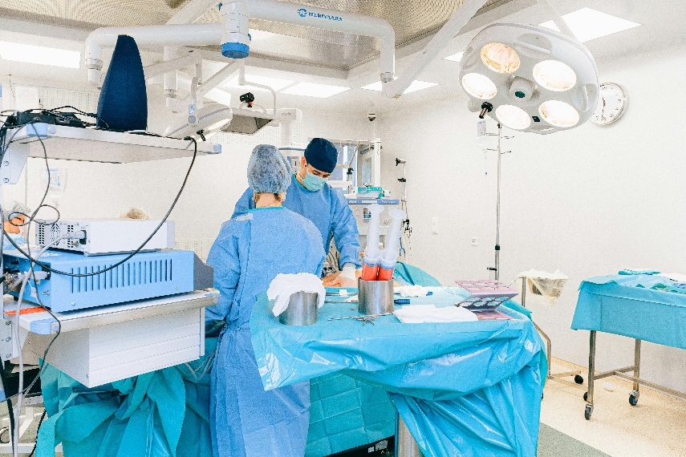
Lecture: A Researcher Reflects on a Completed Observation Study
Dr. Morgan: Good afternoon, everyone. Today, I’ll be sharing our reflections on the naturalistic observation study we conducted in the emergency room (ER). As you know, our goal was to examine how stress impacts communication and teamwork in high-pressure environments. Now that the study is complete, I want to discuss what we learned and the challenges we faced.
Overall, I’m pleased with the study’s procedure. Our decision to conduct overt observation ensured ethical transparency, and the healthcare staff adapted well to the presence of observers. However, we did notice some changes in behavior. Early on, several participants appeared to modify their actions, perhaps to appear more competent or efficient. Fortunately, as the observation continued, this effect diminished, and most participants behaved naturally.
Bias is always a concern in observational studies, and we took steps to minimize it. Our observers underwent rigorous training to ensure consistency and objectivity in recording behaviors. Despite this, subtle biases may have influenced how certain actions were interpreted. For example, one observer consistently rated communication as more effective than others did, suggesting potential subjectivity.
One of the study’s strengths was our use of a structured checklist, which helped standardize data collection. Observers recorded behaviors such as how information was shared during handoffs, how team members responded to high-stress situations, and how leadership roles were enacted. These measures provided us with clear, analyzable data, but unexpected challenges did arise. For instance, the severity of cases during certain shifts created an intensity that was difficult to quantify but undoubtedly influenced behaviors.
One surprise was the level of peer support among the healthcare staff. While we anticipated some collaboration, the extent to which team members relied on one another for emotional and logistical support was striking. This finding highlights the importance of interpersonal relationships in managing stress and maintaining efficiency in the ER.
In terms of ethical considerations, I’m proud to say we adhered to our commitments. All participants were debriefed at the end of the study, and many expressed curiosity about our findings. They appreciated knowing how their contributions would inform improvements in workplace practices.
While the study yielded valuable insights, it also underscored the complexity of naturalistic observations. Contextual factors, such as the time of day or the nature of specific cases, added layers of variability that we couldn’t fully control. Still, these nuances make naturalistic observation such a powerful method for studying real-world behaviors.
In summary, the study was a success, but it also reinforced the importance of flexibility and critical reflection in research. By addressing the challenges and embracing the unexpected, we gained a deeper understanding of the intricate dynamics in high-stress workplaces.

- What was the primary goal of the ER observation study?
- Why was overt observation chosen for this study?
- How did participants initially react to being observed?
- What happened to participants’ behavior as the study progressed?
- How did the researchers minimize bias among observers?
- What tool did the observers use to standardize data collection?
- Name three specific behaviors the observers recorded during the study.
- How did the severity of ER cases affect the study?
- What unexpected finding did the researchers discover about peer support?
- Why was peer support significant in the ER environment?
- What steps were taken to ensure ethical transparency in the study?
- How were participants debriefed at the end of the study?
- Why is debriefing important in psychological research?
- What contextual factors added complexity to the study?
- How did the researchers address variability in their observations?
- Discuss the potential risks of behavioral changes due to overt observation. How could these be minimized in future studies?
- How might observer bias impact the findings of an observational study? What additional steps could be taken to address this?
- Why might naturalistic observation be particularly valuable for studying high-stress workplaces?
- Reflect on how the study’s findings about peer support could inform interventions in other high-stress environments.
- In what ways do contextual factors, such as the time of day or workload intensity, challenge the reliability of naturalistic observation findings?

This worksheet is a free download from TomCoster[dot]com. Please support us by buying a copy of How to succeed at high school or college by Tom Coster – available on Amazon.

