Worksheet: Interviews and Focus Groups as Research Methods in Psychology
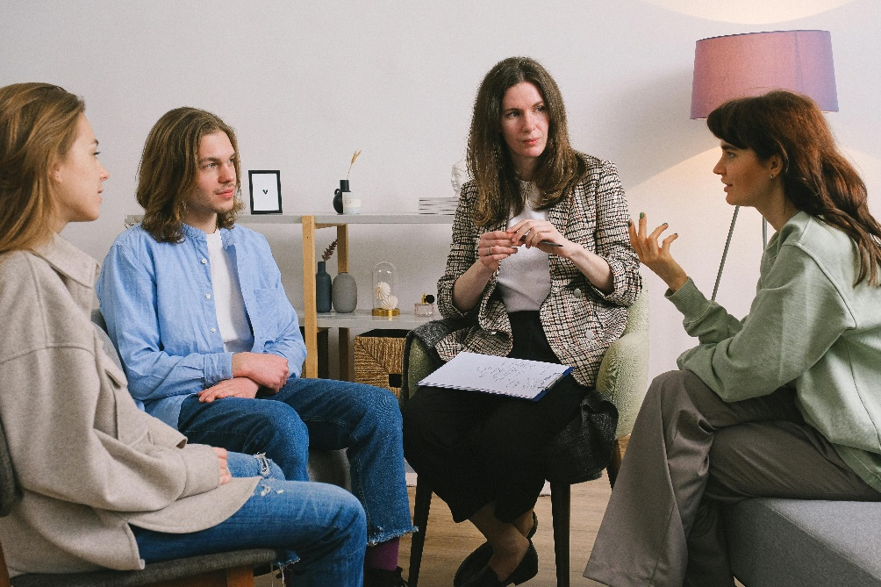
Dialogue: A Psychology Student Shares Their Focus Group Experience
Alex: Hey Mia, I heard you participated in a focus group for a psychology study recently. How was it?
Mia: It was really interesting! The study was about how sleep behavior affects academic results, so it’s something I could really relate to. The focus group had a diverse range of participants. There were students from different programs and years, so the perspectives were really varied.
Alex: That’s cool. Did they explain everything clearly before you started?
Mia: Yeah, they did. The researchers were very thorough. Before we began, they gave us an information sheet explaining the study’s purpose, what we’d be doing, and how our data would be used. Then, they had us sign a consent form. It felt very professional, and they emphasized that participation was voluntary and that we could leave at any time without penalty.
Alex: What about after the session? Did they follow up with anything?
Mia: Yes, they debriefed us at the end. They explained the study’s aim in more detail and answered any questions we had. They also made sure we knew how to contact them if we had any concerns later. I felt really respected throughout the process.
Alex: What was the focus group itself like? How did they structure it?
Mia: It was well-organized. The moderator started with a few open-ended questions like, “How do you think your sleep schedule impacts your academic performance?” and “What factors influence your ability to get quality sleep?” These questions led to some really insightful discussions. They also included some closed questions where we had to rank things, like rating how much we agree with statements such as, “I prioritize sleep over late-night studying.”
Alex: Did everyone get a chance to speak?
Mia: The moderator was great at making sure everyone’s voice was heard. If someone hadn’t spoken in a while, they’d gently ask for their input. It felt very inclusive.
Alex: Sounds like a good experience. Did you find the questions engaging?
Mia: Definitely. The mix of open and closed questions kept it balanced. The open-ended ones encouraged us to share personal experiences, while the closed ones gave structure to the discussion. It made me realize how much I hadn’t thought about the impact of my sleep habits before.
Alex: That sounds fascinating. I’d love to participate in something like that!
Mia: You should! It’s a great way to see psychology research in action and reflect on your own habits too.

- What was the aim of the focus group study Mia participated in?
- What types of participants were included in the study?
- How did the researchers ensure participants understood the study?
- What document did participants sign before the session?
- What assurances were given to participants about their rights?
- What information was provided during the debriefing stage?
- How did the moderator start the focus group discussion?
- Provide an example of an open-ended question asked in the focus group.
- Provide an example of a closed question asked in the focus group.
- Why did the moderator encourage input from all participants?
- How did the mix of open and closed questions benefit the discussion?
- What topic was the focus group study exploring?
- Why is it important to have diverse participants in a focus group?
- How did Mia describe the professionalism of the research process?
- What did Mia learn about her own sleep habits through the study?
- Discuss the advantages of using a focus group to study sleep behavior and academic performance.
- How might the diversity of participants influence the findings of a focus group study?
- What challenges might researchers face in ensuring all voices are heard during a focus group?
- Why is the debriefing stage important in psychological research?
- Reflect on how participating in a focus group might change someone’s awareness of their own behaviors or habits.

This worksheet is a free download from TomCoster[dot]com. Please support us by buying a copy of How to succeed at high school or college by Tom Coster – available on Amazon.

