Worksheet: Understanding Biological Reductionism in the Study of Human Behavior
Biological reductionism is an approach in psychology that seeks to explain complex human behaviors by reducing them to their biological components, such as genetics, brain structures, neurotransmitters, and hormones. It assumes that human behavior can ultimately be understood by examining biological mechanisms. This approach has been incredibly influential, particularly in fields such as neuroscience, psychopharmacology, and genetics, providing valuable insights into mental health conditions, addiction, and personality traits. For instance, research into dopamine's role in schizophrenia or serotonin's involvement in depression has led to effective drug treatments, significantly improving the quality of life for many people.
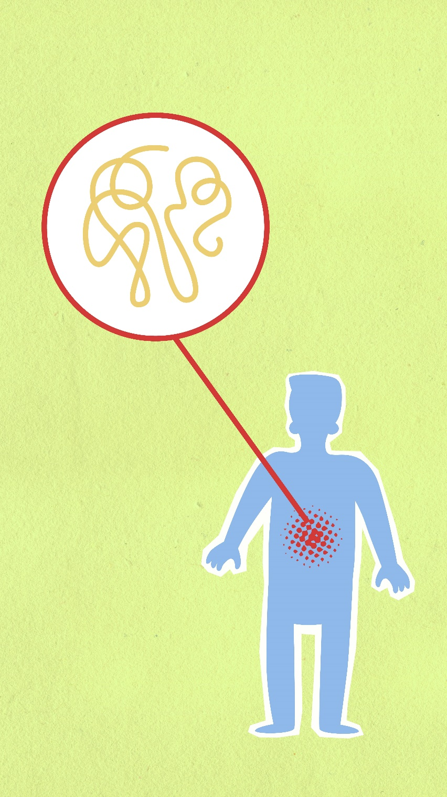
One of the key strengths of biological reductionism is its scientific rigor. By focusing on measurable, observable biological processes, this approach lends itself to precise experimental methods, which allow for clear hypotheses and replicable results. This has made it possible to establish causal relationships between biological factors and behavior, enabling the development of interventions like medications and brain stimulation therapies. Additionally, biological reductionism has contributed to a deeper understanding of the interaction between biology and behavior, helping to destigmatize mental health issues by framing them as medical conditions rather than personal failings.
However, biological reductionism also has significant limitations. Critics argue that it oversimplifies human behavior by neglecting the complexity of psychological, social, and environmental influences. Human behavior is rarely driven by biology alone; factors such as upbringing, culture, personal experiences, and social interactions play critical roles. For example, while genetic predispositions might contribute to conditions like depression, environmental stressors often trigger or exacerbate these issues. This reductionist approach can also lead to a deterministic view of behavior, implying that individuals have little control over their actions, which may undermine personal responsibility and the role of free will.
Moreover, an over-reliance on biological explanations may overlook the importance of holistic or integrative approaches, which consider the interplay between biology, psychology, and environment. For instance, while antidepressant medication addresses the biological symptoms of depression, therapy and social support are crucial for addressing the psychological and social dimensions of the condition. A balanced perspective that acknowledges the strengths of biological reductionism while recognizing its limitations is essential for a comprehensive understanding of human behavior.
- What is biological reductionism?
- Name three biological components often studied in biological reductionism.
- How has biological reductionism contributed to our understanding of mental health conditions?
- What is an example of a neurotransmitter linked to a psychological condition?
- Why is biological reductionism considered a scientific approach?
- What are the advantages of focusing on measurable biological processes in research?
- How has biological reductionism helped reduce the stigma surrounding mental health?
- What types of treatments have emerged from a biological reductionist perspective?
- Why is experimental replicability considered a strength of this approach?
- Why do critics argue that biological reductionism oversimplifies human behavior?
- Give an example of how environmental factors interact with biological predispositions in influencing behavior.

- What is a deterministic view of behavior, and why is it controversial?
- Why might biological reductionism fail to address the role of culture in shaping human behavior?
- What are the risks of overlooking holistic or integrative approaches to treatment?
- Do you think all human behaviors can be reduced to biological components? Why or why not?
- What are some potential ethical concerns with adopting a purely biological approach to behavior?
- How might biological reductionism influence the way society views personal responsibility?
- Consider a condition like addiction: how might biological reductionism and a holistic approach differ in explaining and treating it?
- What are the implications of focusing solely on biological explanations for mental health treatment programs?
- In what ways could a more integrative approach enhance the strengths of biological reductionism?

This worksheet is a free download from TomCoster[dot]com. Please support us by buying a copy of How to succeed at high school or college by Tom Coster – available on Amazon.

