Worksheet: Neurotransmission and Applications to Health and Wellness
Article: Neurotransmission Beyond Depression: Insights and Applications

Neurotransmission, the process by which neurons communicate through chemical messengers, plays a critical role in maintaining the body’s physiological and psychological balance. While much attention is given to the relationship between serotonin and depression, other neurotransmitters and their roles in health and wellness offer equally compelling insights.
Dopamine, often referred to as the "reward neurotransmitter," is central to processes like movement, motivation, and reward-based learning. Its dysfunction is implicated in conditions such as Parkinson’s disease and addiction. In Parkinson’s, the loss of dopamine-producing neurons leads to motor symptoms like tremors, stiffness, and slowed movement. Treatments such as dopamine agonists or Levodopa work by replenishing or mimicking dopamine, helping to manage symptoms and improve patients’ quality of life.
In the realm of addiction, understanding dopamine pathways has led to interventions aimed at reducing substance dependence. Drugs of abuse, such as cocaine or opioids, hijack the brain’s reward system, leading to exaggerated dopamine release. Behavioral therapies and medications, like naltrexone, target these pathways to restore balance and support recovery.
Another critical neurotransmitter is acetylcholine, which influences memory, learning, and muscle function. Alzheimer’s disease, a neurodegenerative disorder, involves the loss of cholinergic neurons, leading to memory deficits and cognitive decline. Treatments such as cholinesterase inhibitors increase acetylcholine levels, temporarily improving symptoms and enhancing the quality of life for patients and caregivers.
Gamma-aminobutyric acid (GABA), the brain’s primary inhibitory neurotransmitter, regulates anxiety and prevents overexcitement of neural circuits. Conditions like generalized anxiety disorder and epilepsy are linked to imbalances in GABA activity. Benzodiazepines, which enhance GABA’s effects, are commonly used to treat anxiety and seizures, though their potential for dependence necessitates careful monitoring.
Research on neurotransmission has also spurred innovation in non-pharmacological treatments. For example, transcranial magnetic stimulation (TMS) uses magnetic fields to stimulate specific brain areas, promoting changes in neurotransmitter activity. TMS has been effective for conditions like treatment-resistant depression, chronic pain, and even tinnitus.
Ethical considerations are paramount as advancements in understanding neurotransmission continue. Questions about access to treatments, potential misuse of neuroenhancement technologies, and the stigma surrounding neurological conditions need careful navigation. Additionally, cultural perspectives may influence how societies approach treatments and prioritize mental and neurological health.
Neurotransmission provides a window into the intricate workings of the brain, offering tools to address diverse health challenges. By broadening our focus, we can unlock innovative approaches to improving human well-being.

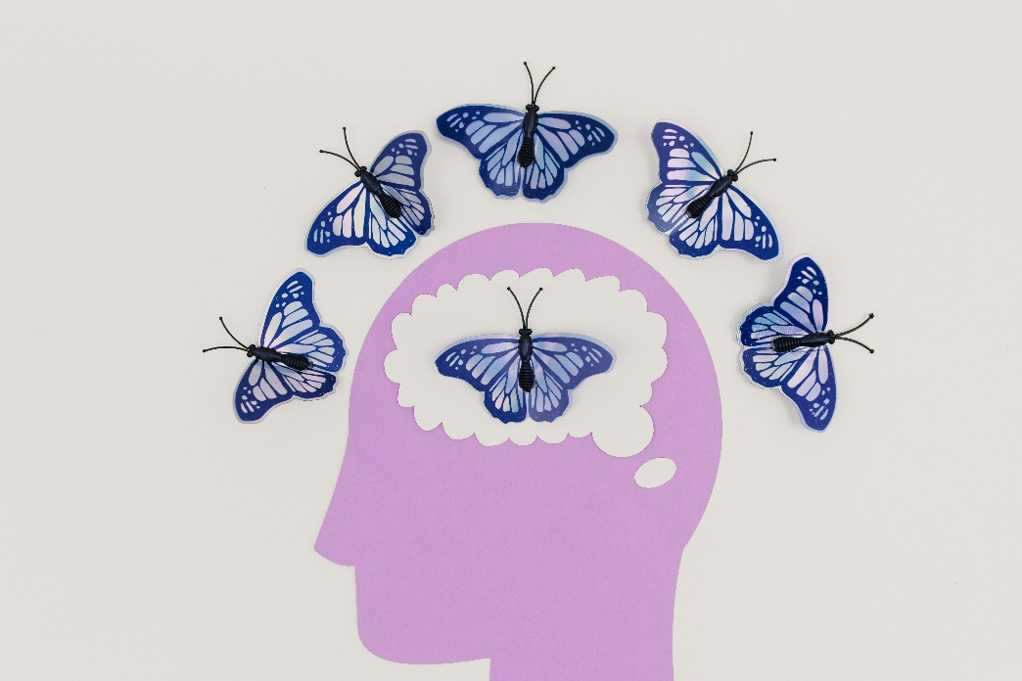
- What is neurotransmission, and why is it important for overall health?
- Explain the role of dopamine in reward-based learning and movement.
- How does dopamine dysfunction contribute to Parkinson’s disease?
- Describe how Levodopa helps manage Parkinson’s symptoms.
- How do drugs of abuse affect the brain’s dopamine pathways?
- What is the function of acetylcholine in the brain?
- How is acetylcholine involved in Alzheimer’s disease?
- Explain the mechanism of cholinesterase inhibitors in treating Alzheimer’s.
- What role does GABA play in regulating brain activity?
- How are benzodiazepines used to treat anxiety and epilepsy?
- What is transcranial magnetic stimulation (TMS), and how does it work?
- List three conditions that TMS has been used to treat.
- Why is it essential to consider ethical concerns in neurotransmission research?
- How do cultural perspectives shape approaches to neurological treatments?
- What are some non-pharmacological approaches influenced by neurotransmission research?
- How might our understanding of neurotransmission influence future treatments for addiction?
- What are the potential risks of relying heavily on pharmacological treatments for neurotransmitter imbalances?
- Should neuroenhancement technologies be regulated? Why or why not?
- How can healthcare systems ensure equitable access to treatments based on neurotransmission research?
- In what ways can public education about neurotransmission reduce stigma around neurological and mental health conditions?

This worksheet is a free download from TomCoster[dot]com. Please support us by buying a copy of How to succeed at high school or college by Tom Coster – available on Amazon.

