Worksheet: Neurotransmission and Its Role in Health and Wellness
Dialogue: Professor’s Lecture on Neurotransmission and Health

Professor Carter: Good afternoon, everyone! Today, we’re looking at neurotransmission to understand how this process has revolutionized psychology and healthcare. Let’s start with the basics.
Neurotransmission is the process by which neurons, the brain’s communication cells, transmit signals. Neurons don’t physically touch; instead, they communicate across tiny gaps called synapses. When a neuron is activated, it releases chemical messengers called neurotransmitters into the synapse. These neurotransmitters bind to receptor sites on the receiving neuron, which either excites or inhibits the signal.
Common neurotransmitters include serotonin, dopamine, and GABA. Each has a distinct role. For example, serotonin helps regulate mood, appetite, and sleep. Low serotonin levels are often linked to depression, which is why many antidepressants aim to increase serotonin activity. Dopamine, on the other hand, is central to reward and motivation, while GABA acts as the brain’s calming agent, reducing anxiety and stress.
Student: Professor, how does this knowledge improve health and wellness?
Professor Carter: Excellent question! By understanding neurotransmission, psychologists and healthcare professionals can develop targeted treatments for mental and physical health conditions. For instance, selective serotonin reuptake inhibitors (SSRIs) are a class of medications that block the reabsorption of serotonin in the brain, allowing it to remain active longer. This mechanism helps alleviate symptoms of depression and anxiety.
Another example is the treatment of Parkinson’s disease, which involves the neurotransmitter dopamine. Parkinson’s occurs when dopamine-producing neurons in the brain degenerate. Medications like Levodopa help replenish dopamine levels, improving motor function.
Student: Are there non-medication approaches that involve neurotransmission?
Professor Carter: Absolutely. Cognitive-behavioral therapy (CBT) has been shown to affect neurotransmission. For example, CBT can increase serotonin levels by encouraging positive thought patterns and reducing stress. Physical activities like exercise also boost dopamine and endorphin levels, which improve mood and reduce anxiety.
Student: Does understanding neurotransmission raise ethical concerns?
Professor Carter: It can. For example, the rise of neuroenhancement tools, like stimulants to boost focus, raises questions about fairness and potential misuse. Additionally, the stigma surrounding mental health conditions related to neurotransmitter imbalances needs to be addressed. Ethical considerations are essential when applying this knowledge to ensure it benefits everyone.
Professor Carter: In summary, neurotransmission is a cornerstone of our understanding of mental health and wellness. By continuing to explore this process, we can develop more effective treatments and interventions, improving lives worldwide. Now, let’s move on to some case studies to deepen your understanding.

- What is neurotransmission?
- Define the role of a synapse in neurotransmission.
- Name three common neurotransmitters and their primary functions.
- How does serotonin influence mood and health?
- What is the relationship between dopamine and motivation?
- Describe how GABA affects the brain.
- What happens when neurotransmitters bind to receptor sites on the receiving neuron?
- Explain the mechanism of action for selective serotonin reuptake inhibitors (SSRIs).
- How does Levodopa help manage Parkinson’s disease?
- What is the connection between exercise and neurotransmitters?
- How does cognitive-behavioral therapy (CBT) influence neurotransmission?
- Why is dopamine important in the context of reward systems?
- What are the effects of low serotonin levels on mental health?
- How does the degeneration of dopamine-producing neurons lead to Parkinson’s symptoms?
- What role do receptor sites play in neurotransmission?
- How might understanding neurotransmission change the way society views mental health conditions?
- Should neuroenhancement tools be made widely available? Why or why not?
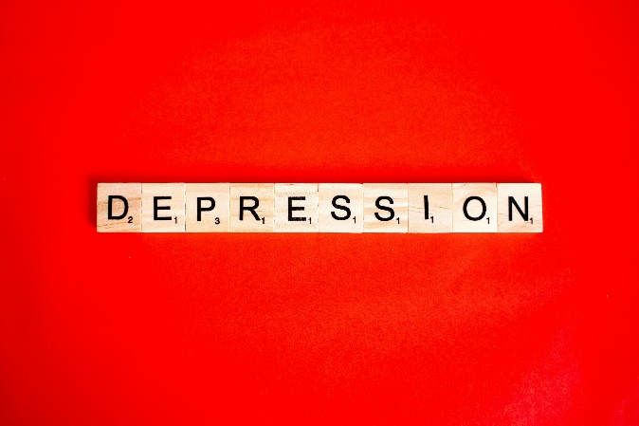
- What are the potential risks of over-relying on medication to address neurotransmitter imbalances?
- How can psychologists and educators use knowledge of neurotransmission to reduce stigma around mental health?
- In what ways can non-medication treatments, like therapy or lifestyle changes, complement medication in addressing neurotransmitter-related conditions?

This worksheet is a free download from TomCoster[dot]com. Please support us by buying a copy of How to succeed at high school or college by Tom Coster – available on Amazon.

