Worksheet: The Role of the Hippocampus in the Memory Process
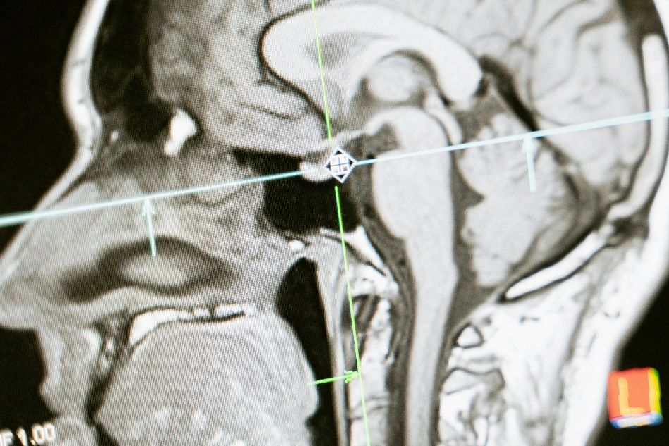
Dialogue: Two Students Discuss the Role of the Hippocampus
Emily: Hey Jack, I’m going through my notes on memory for the exam, but I’m stuck on the role of the hippocampus. Can you help me out?
Jack: Sure, Emily! The hippocampus is like the brain’s filing clerk. It’s in the medial temporal lobe and helps organize and consolidate information from short-term memory into long-term memory.
Emily: So, if I’m learning about memory for the test, my hippocampus is storing that information for later?
Jack: Exactly. It takes the bits of information you’re learning now and helps you store them as long-term memories. Without the hippocampus, you’d struggle to form new declarative memories—those are memories of facts and events.
Emily: Declarative memories, like remembering what we talked about in class yesterday?
Jack: Yes! A famous case that shows this is Henry Molaison, or H.M. After his hippocampi were removed to treat epilepsy, he couldn’t form new long-term memories. He could remember things from before the surgery, but he couldn’t learn new facts or recall events after it.
Emily: Oh, I remember that case. It shows how vital the hippocampus is for new learning. But what about other types of memory, like skills or habits?
Jack: Good question. Procedural memories, like learning to ride a bike, are handled by other brain regions, like the cerebellum. H.M. could still learn new skills, even though he couldn’t remember learning them.
Emily: That’s fascinating. Does the hippocampus have any other roles in memory?
Jack: Yes, it’s also involved in spatial memory, which helps us navigate. Studies on London taxi drivers showed that their hippocampi were larger than average, likely because they memorized the city’s layout.
Emily: So it’s not just for storing facts and events but also for helping us find our way around?
Jack: Exactly. It’s like a mental GPS. But the hippocampus is also sensitive to stress. High levels of cortisol, the stress hormone, can shrink the hippocampus and impair memory.
Emily: Wow, so chronic stress can actually damage the hippocampus?
Jack: Yes, but the good news is that activities like regular exercise and mindfulness can help protect and even improve its function.
Emily: That’s reassuring. Does the hippocampus work alone in memory processes?
Jack: Not at all. It works closely with the amygdala for emotional memories and the prefrontal cortex for organizing and retrieving memories. It’s part of a larger network.
Emily: That makes sense. So, the hippocampus is a team player when it comes to memory. Thanks, Jack! I feel like I understand this much better now.

- Where is the hippocampus located in the brain?
- What is the primary function of the hippocampus?
- How does the hippocampus contribute to memory consolidation?
- What type of memory is most affected by damage to the hippocampus?
- Who was Henry Molaison (H.M.), and why is his case significant?
- What are declarative memories, and how are they related to the hippocampus?
- What type of memory was H.M. still able to learn after his surgery?
- What is the role of the hippocampus in spatial memory?
- What study showed that London taxi drivers had larger hippocampi?
- How does the hippocampus act as a “mental GPS”?
- What hormone affects the hippocampus during stress?
- How does chronic stress impact the hippocampus?
- What activities can protect or improve hippocampal function?
- Which other brain regions work with the hippocampus in memory processes?
- How does the hippocampus interact with the amygdala in emotional memories?
- Why might understanding the hippocampus be important in treating memory disorders?
- What ethical considerations arise when studying individuals with hippocampal damage?
- How might neuroplasticity in the hippocampus be harnessed to improve memory in people with cognitive impairments?
- What strategies could be implemented to mitigate the effects of stress on the hippocampus?
- Reflect on your own learning experience. How do you think the hippocampus supports your ability to retain information for exams?

This worksheet is a free download from TomCoster[dot]com. Please support us by buying a copy of How to succeed at high school or college by Tom Coster – available on Amazon.

