Worksheet: The Role of the Hippocampus in the Memory Process
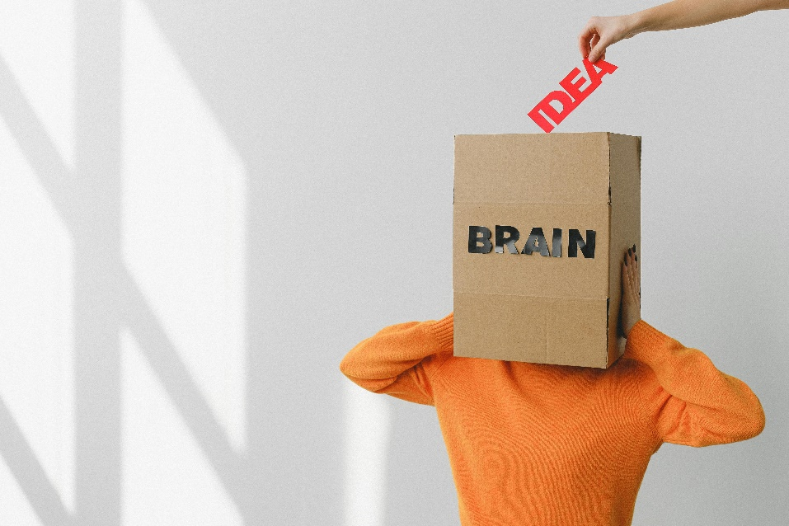
‘Understanding the Role of the Hippocampus in Memory’ by Dr. Claire Morgan, Psychology Professor
Good morning, class. Today, we’re focusing on the hippocampus, a vital structure in the brain's memory system. This small, seahorse-shaped structure, located in the medial temporal lobe, plays a crucial role in how we create, store, and retrieve memories.
The hippocampus is best known for its role in memory consolidation—the process of transferring information from short-term to long-term memory. For example, when you study for an exam, the hippocampus helps encode the material so it can be retrieved later. It acts like a bridge between immediate experiences and long-term knowledge storage.
One of the most famous cases highlighting the hippocampus’ role in memory is that of Henry Molaison (H.M.). After undergoing surgery to remove his hippocampi to treat severe epilepsy, H.M. lost the ability to form new long-term memories, although his short-term memory and procedural memory, like learning new skills, remained intact. This case demonstrated that the hippocampus is critical for declarative memory—our ability to recall facts and events.
The hippocampus also plays a role in spatial memory, which helps us navigate our environment. Taxi drivers in London, for instance, have been shown to have larger hippocampi than average, a result of memorizing the city’s complex street layout. This highlights the brain’s ability to adapt based on experience—a concept known as neuroplasticity.
Interestingly, the hippocampus is highly sensitive to stress. Chronic stress can shrink the hippocampus and impair memory formation and retrieval. This is due to elevated levels of cortisol, which can damage hippocampal neurons over time. However, activities like regular exercise, sufficient sleep, and mindfulness practices have been shown to protect and even improve hippocampal function.
While the hippocampus is essential, it doesn’t work in isolation. It collaborates with other brain regions, such as the amygdala, to process emotional memories, and the prefrontal cortex, which plays a role in organizing and retrieving memories. These interactions show how complex and interconnected the memory process is.
In conclusion, the hippocampus is a cornerstone of our memory system, influencing how we store experiences, navigate our environment, and recall important information. Understanding its role not only enhances our knowledge of cognition but also informs strategies for maintaining brain health and managing conditions like Alzheimer’s disease and PTSD.
- Where is the hippocampus located in the brain?
- What is the primary function of the hippocampus in memory?
- What is memory consolidation, and how does the hippocampus contribute to it?
- What type of memory was most affected in Henry Molaison (H.M.) after his surgery?
- Why was H.M. still able to learn new procedural skills despite losing the ability to form new declarative memories?
- What role does the hippocampus play in spatial memory?
- How does the study of London taxi drivers support the idea of neuroplasticity?
- How does chronic stress affect the hippocampus?
- What hormone is associated with hippocampal damage due to stress?
- What activities can protect and improve hippocampal function?
- How does the hippocampus work with the amygdala in memory processing?
- What role does the prefrontal cortex play in memory retrieval?
- Why is the hippocampus considered essential for declarative memory?
- What are some strategies to maintain hippocampal health?
- How does the hippocampus demonstrate the interconnectedness of brain regions in memory processes?
- Why might spatial memory be more developed in certain professions, such as taxi driving?
- How could understanding the effects of stress on the hippocampus inform interventions for stress-related memory problems?
- What ethical considerations arise in studying individuals with hippocampal damage, such as H.M.?
- How might neuroplasticity in the hippocampus be harnessed to treat memory-related disorders?
- Reflect on a time when you relied on spatial memory. How do you think the hippocampus contributed to that experience?

This worksheet is a free download from TomCoster[dot]com. Please support us by buying a copy of How to succeed at high school or college by Tom Coster – available on Amazon.

