Worksheet: Investigating Spatial Memory in Taxi Drivers Using MRI
In 2000, Eleanor Maguire and her colleagues conducted a seminal study examining the brains of London taxi drivers to understand the neural basis of spatial memory. Utilizing Magnetic Resonance Imaging (MRI), they aimed to determine whether the extensive navigation experience of taxi drivers was associated with structural differences in the hippocampus, a region implicated in memory and spatial navigation.
The study involved 16 right-handed male London taxi drivers, each with a minimum of two years’ experience, and a control group of 50 right-handed male non-taxi drivers. All participants underwent MRI scans to assess the structure of their hippocampi. The researchers employed voxel-based morphometry (VBM) to analyze differences in gray matter density between the two groups.
The results revealed that the posterior hippocampi of taxi drivers were significantly larger than those of the control group, while the anterior hippocampi were smaller. Moreover, a positive correlation was found between the volume of the posterior hippocampus and the length of time spent as a taxi driver, suggesting that the demands of extensive navigation experience can lead to structural changes in the brain. This finding supports the concept of neuroplasticity, indicating that the brain can adapt structurally in response to environmental demands.
Maguire et al.’s study provided compelling evidence for the role of the hippocampus in spatial memory and navigation. It demonstrated that the human brain is capable of undergoing structural changes in response to the cognitive demands of one’s environment and occupation. These insights have broader implications for understanding how specialized experiences can shape brain anatomy and function.
- What was the primary aim of Maguire et al.’s (2000) study?
- Which brain imaging technique was used in this research?
- How many participants were in the taxi driver group, and what were their characteristics?
- What was the composition of the control group in the study?
- What specific brain region did the researchers focus on?
- Describe the main structural difference found in the hippocampi of taxi drivers compared to the control group.
- What is voxel-based morphometry (VBM), and why was it used in this study?
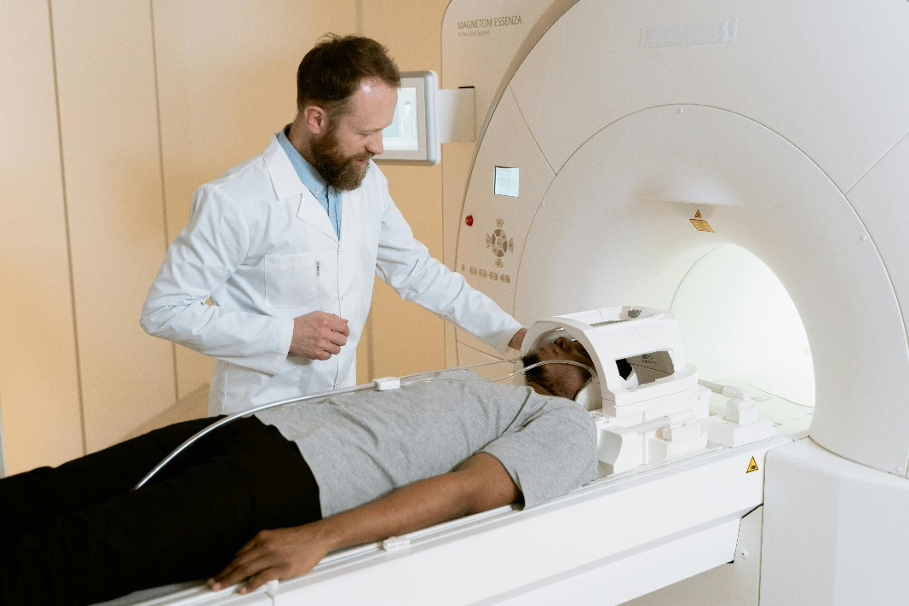
- How did the length of time spent as a taxi driver relate to hippocampal structure?
- What concept explains the brain’s ability to change structurally in response to environmental demands?
- What are the primary functions associated with the hippocampus?
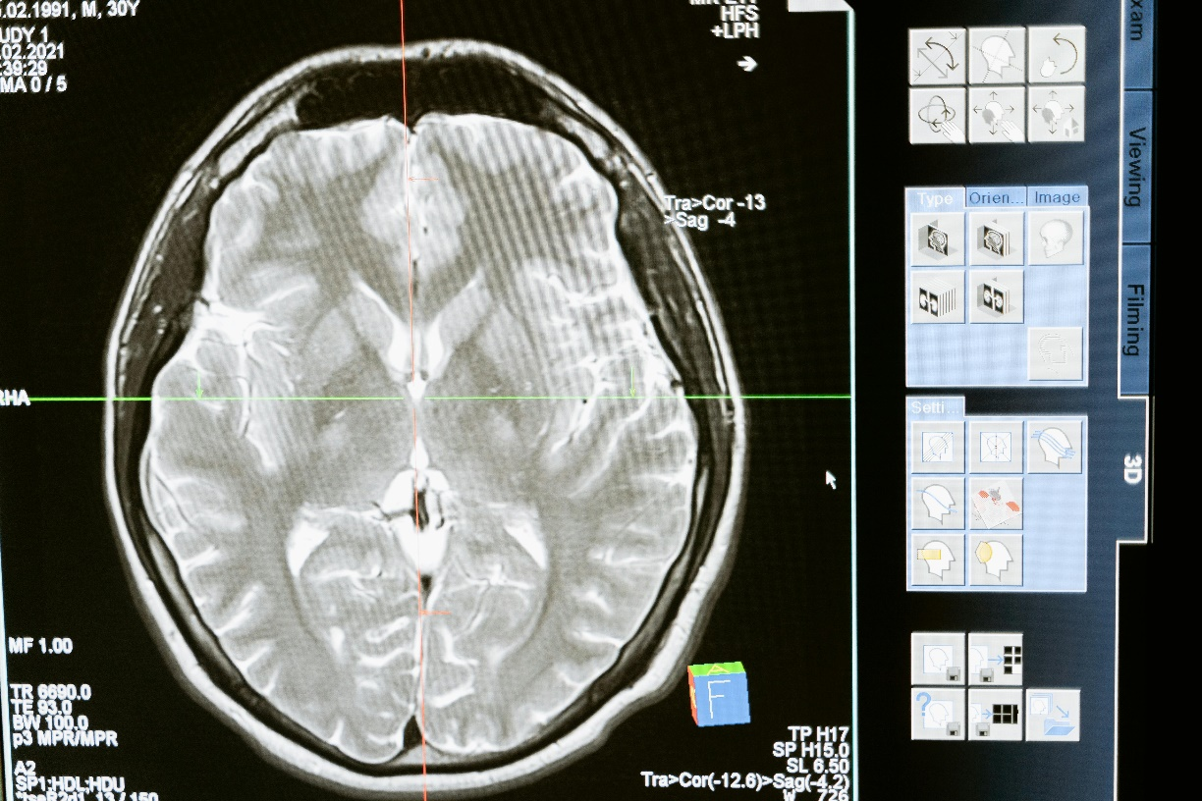
- Why were only right-handed male participants selected for this study?
- What does the study suggest about the relationship between professional experience and brain structure?
- How might these findings be relevant to professions other than taxi driving?
- What are some limitations of using MRI in studies like this?
- How does this study contribute to our understanding of the localization of brain function?
- Considering the study’s findings, how might engaging in activities that require extensive spatial navigation affect individuals not professionally involved in such tasks?
- What ethical considerations should be taken into account when conducting neuroimaging studies on specific occupational groups?
- How could future research build upon Maguire et al.’s findings to explore the effects of other types of expertise on brain structure?
- In what ways might advancements in neuroimaging technology enhance our understanding of the relationship between experience and brain anatomy?
- Discuss the potential implications of neuroplasticity for rehabilitation programs aimed at individuals with hippocampal damage.

Extension Activity
Imagine you are a researcher designing a follow-up study to Maguire et al. What would you change or add? Consider: A different population (e.g., delivery drivers, pilots, or gamers). Including female participants to explore potential gender differences in hippocampal structure and spatial memory. Longitudinal designs to investigate how these changes develop over time.
Write a brief proposal (150-200 words) outlining your study’s aims, methods, and predicted outcomes.

This worksheet is a free download from TomCoster[dot]com. Please support us by buying a copy of How to succeed at high school or college by Tom Coster – available on Amazon.

