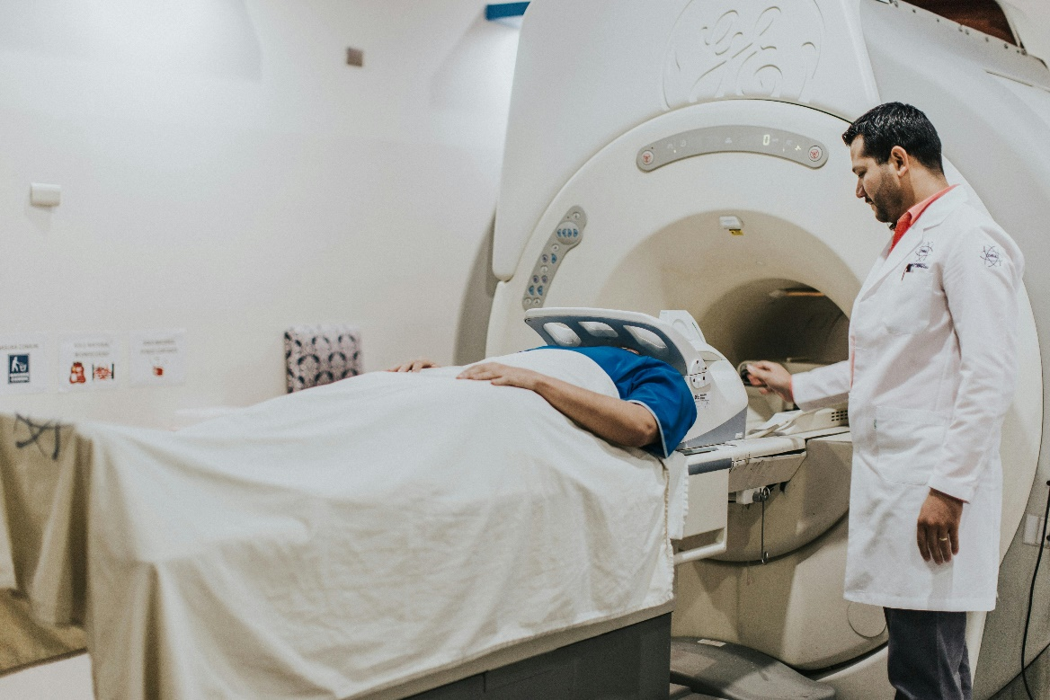
Worksheet: The Value of Brain Imaging Techniques in Investigating Human Behavior
Brain imaging techniques have revolutionized the study of human behavior by providing researchers with tools to observe and analyze the brain’s structure and function. Techniques such as functional magnetic resonance imaging (fMRI), positron emission tomography (PET), and electroencephalography (EEG) allow scientists to explore the neural underpinnings of behaviors like memory, thinking, and decision-making in unprecedented detail.
For example, fMRI measures changes in blood flow to different areas of the brain, providing insight into which regions are active during specific cognitive tasks. This has been instrumental in understanding processes like memory formation and retrieval. Studies have shown that the hippocampus plays a critical role in storing and recalling memories, while the prefrontal cortex is heavily involved in decision-making and problem-solving. PET scans, which use radioactive tracers to measure metabolic activity, have similarly contributed to understanding how the brain functions in disorders like Alzheimer’s disease. EEG, which records electrical activity in the brain, is particularly valuable for studying rapid processes like decision-making and attention.
The value of these techniques lies not only in their ability to pinpoint the biological basis of behavior but also in their contribution to practical applications. For instance, brain imaging has helped develop treatments for neurological and psychological conditions, from targeting specific areas of the brain in depression therapy to designing interventions for individuals with memory deficits. It has also provided critical insights into how decisions are influenced by factors like stress, risk, and reward.
However, brain imaging techniques are not without limitations. While they provide a wealth of data, interpreting this information can be challenging. Correlation does not equal causation, and it’s often difficult to determine whether observed brain activity directly causes a behavior. Additionally, brain imaging studies are expensive, and the artificial environment of a scanner may not always reflect real-world conditions. Despite these limitations, the ability to observe the brain in action offers a powerful tool for advancing our understanding of human cognition and behavior.
- What are three examples of brain imaging techniques used in psychology?
- How does fMRI measure brain activity?
- What is the primary purpose of PET scans?
- Which brain imaging technique is most useful for studying rapid processes like attention and decision-making?
- Name two brain regions mentioned in the text and their associated functions.
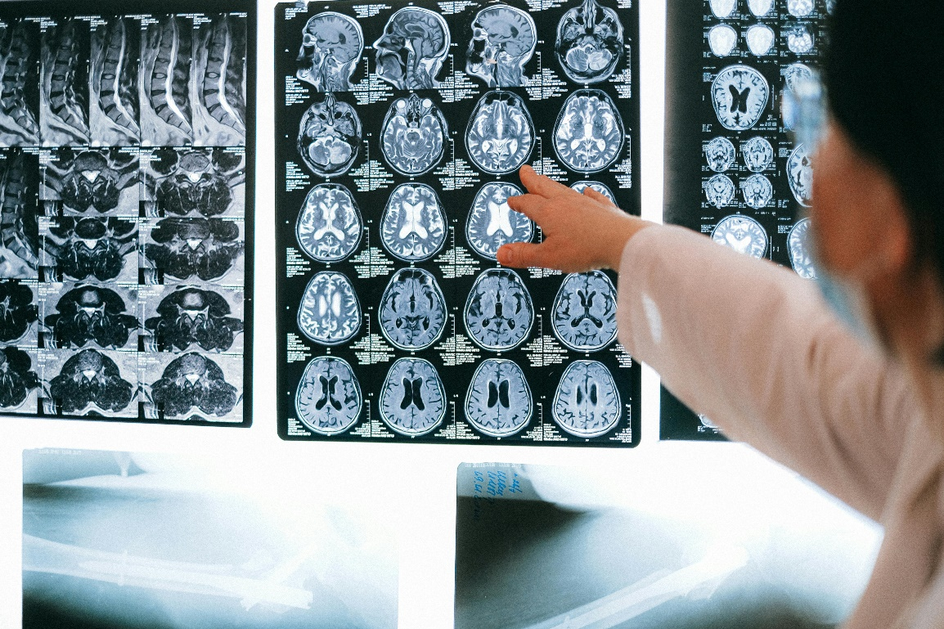
- How has brain imaging contributed to understanding memory?
- What role does the hippocampus play in memory processes?
- Why is the prefrontal cortex important in decision-making?
- How can brain imaging help in the treatment of psychological or neurological conditions?
- Give an example of how brain imaging has been used to study a specific disorder.
- What is one strength of using brain imaging techniques in psychological research?
- Why might the artificial environment of a scanner be a limitation?
- Explain why “correlation does not equal causation” in the context of brain imaging studies.
- Why is the cost of brain imaging considered a limitation?
- What challenges do researchers face when interpreting brain imaging data?
- Do you think brain imaging techniques are always necessary for studying human behavior? Why or why not?
- How might cultural or environmental factors influence the results of brain imaging studies?
- In what ways could brain imaging techniques be misused or misinterpreted in research or society?
- Consider a behavior like decision-making. How could combining brain imaging with other research methods provide a more comprehensive understanding?
- What ethical considerations should researchers keep in mind when using brain imaging techniques, particularly in clinical populations?

This worksheet is a free download from TomCoster[dot]com. Please support us by buying a copy of How to succeed at high school or college by Tom Coster – available on Amazon.

