Worksheet: Animal Research in the Study of Human Behavior
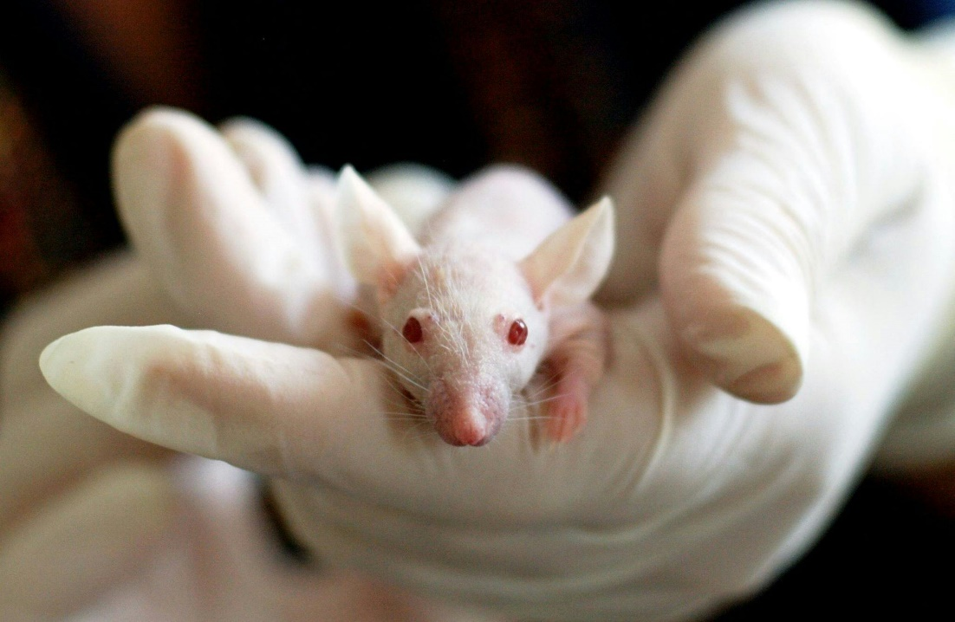
Animal research has played a pivotal role in advancing our understanding of human behavior, providing insights into complex psychological and physiological processes that would be difficult or impossible to study directly in humans. Animals, such as rats, monkeys, and pigeons, share many biological and neurological similarities with humans, making them valuable models for exploring topics like learning, memory, and the effects of drugs on behavior. Groundbreaking studies, such as Pavlov’s work on classical conditioning and Harlow’s research on attachment, have relied on animal subjects to develop theories that form the foundation of modern psychology.
However, the use of animals in research raises important ethical considerations. Many believe that animals experience emotions similar to humans, such as loneliness, happiness, fear, and even grief. For instance, research has shown that primates form strong social bonds, rats show signs of distress when separated from their peers, and dogs can exhibit behaviors indicative of joy or anxiety. Recognizing these emotional capacities raises moral concerns about subjecting animals to research that involves suffering or pain. Experiments that cause fear, isolation, or physical harm may lead to significant emotional distress for the animal, further complicating the ethical balance between scientific benefit and animal welfare.
Ethical guidelines, such as those outlined by the American Psychological Association (APA) or the British Psychological Society (BPS), emphasize the importance of minimizing pain and suffering, using alternatives wherever possible, and ensuring that the scientific benefits outweigh the ethical costs. By adhering to these standards, researchers aim to respect the welfare of animals while contributing valuable knowledge to the field of psychology. Nonetheless, this remains a contentious area, with ongoing debates about the moral implications of using sentient, emotionally complex beings in research.

- Why are animals often used in psychological research?
- What are some examples of animal studies that have contributed to our understanding of human behavior?
- Name three biological or neurological similarities between humans and animals that justify their use in research.
- What is the primary ethical dilemma involved in animal research?
- List two ethical guidelines researchers must follow when using animals in research.
- What does the principle of minimizing harm mean in the context of animal research?
- What are some alternatives to using animals in psychological research?
- How do researchers ensure that the benefits of their work outweigh the ethical costs?
- What role do oversight committees, such as Institutional Animal Care and Use Committees (IACUC), play in animal research?
- Describe one criticism of animal research and how researchers address this concern.
- What is the significance of using species-specific knowledge (e.g., understanding the natural behavior of the animal) in research design?
- How does the principle of “replacement, reduction, and refinement” (the 3Rs) guide ethical animal research?
- What does it mean to “generalize findings” from animal studies to human behavior? Why is this sometimes controversial?
- Explain why Harlow’s research on attachment is considered both groundbreaking and ethically controversial.
- In what ways has animal research contributed to the development of treatments for psychological or medical conditions in humans?
- Why do you think some people argue against using animals in research, even if the studies lead to significant scientific breakthroughs? How would you respond to these arguments?
- Consider a psychological study using animals where the results were later applied to humans. What factors could affect how validly the findings translate from animals to humans?
- If technological advancements made it possible to completely replace animals in research, would there still be any justification for using them? Why or why not?
- How might cultural or societal values influence a person’s perspective on the ethics of animal research? Provide examples to support your answer.
- Imagine you are part of a research ethics committee reviewing a study proposal involving animals. What key questions would you ask to determine if the study is ethically justified?

This worksheet is a free download from TomCoster[dot]com. Please support us by buying a copy of How to succeed at high school or college by Tom Coster – available on Amazon.

